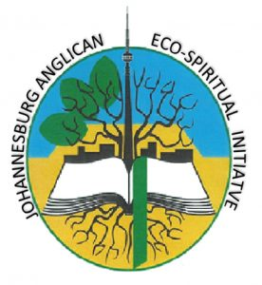
JAEI Programme Supporter
The Johannesburg Anglican Eco-spiritual Initiative is a formal body of the Diocese of Johannesburg, seeking to meet the challenges being faced by this generation with regards to the environment. We believe it is God's will that we look after this precious planet we call home.
Guided by our Diocesan vision, JAEI encourages all parishes and Diocesan organisations to pursue responsible environmental management through:
- Visionary servant leadership from within the parish or organisation
- Developing a vibrant community who are committed to a sustainable environment
- Focused partnerships with nearby communities where possible
Focus on Eco-ministry activities include:
- Compliance with applicable legislation
- Embodying and proclaiming the message of God’s redemptive hope and healing for all creation
- Preaching and practising ‘Reverence for Creation’
- Integrating environmental awareness into our worship and other group activities
- Creating awareness and enhancing the environmental knowledge of our members
- Empower environmental action & responsibility by reducing the ecological footprint of the parish or organisation
- Meeting sound environmental practices as far as possible and encouraging our members to do the same at home, in their communities and their places of work.
- Evaluating performance regularly and improving this where possible

Should you feel moved to support the work of JAEI – this would be highly appreciated!
Please complete the section below and return to Mark Franklin (markfranklin483@gmail.com ) Should you wish to discuss this, please contact Mark by email or on 083 378 2092

I/we would like to support JAEI’s work
First name:
Last name:
Cell: |  | Landline:
Email:
Postal address
I/we would like to contribute R…………. per month/per annum to the work of JAEI from
Date start ………………… Date end …………………….
Or
I/we would like to contribute R………………once off to the work of JAEI.
Please make an Electronic Funds Transfer (EFT) to the following
Banking details: | Standard Bank  Branch Code: 001805:  Diocesan Deposit Fund  Account number:001302353  Reference: 8555 followed by your name. This is very important.

Your generous support of the work of JAEI is much appreciated – THANK YOU!

