JAEI ENVIRONMENTAL CORNER
Look up! – October skies …

Psalm 19:1-6
NIV | The Message
¹ The heavens declare the glory of God;  the skies proclaim the work of his hands.  ² Day after day they pour forth speech;  night after night they reveal knowledge.  ³ They have no speech, they use no words;  no sound is heard from them.  ⁴ Yet their voice goes out into all the earth,  their words to the ends of the world.  In the heavens God has pitched a tent for the sun.  ⁵ It is like a bridegroom coming out of his chamber,  like a champion rejoicing to run his course.  ⁶ It rises at one end of the heavens  and makes its circuit to the other;  nothing is deprived of its warmth. | 19 ¹⁻² God’s glory is on tour in the skies,  God-craft on exhibit across the horizon.  Madame Day holds classes every morning,  Professor Night lectures each evening.  ³⁻⁴ Their words aren’t heard,  their voices aren’t recorded,  But their silence fills the earth:  unspoken truth is spoken everywhere.  ⁴⁻⁵ God makes a huge dome  for the sun—a superdome!  The morning sun’s a new husband  leaping from his honeymoon bed,  The day-breaking sun an athlete  racing to the tape.  ⁶ That’s how God’s Word vaults across the skies  from sunrise to sunset,  Melting ice, scorching deserts,  warming hearts to faith.

We don’t often take time out to look up & marvel at the heavens! Johannesburg, of course, isn’t the best place to view the night skies as there is too much in the way of light pollution, but the more dominant constellations and stars are visible. So take time to LOOK UP sometime this month ….. !

(Taken directly from http://www.saao.ac.za/whats-up )
What’s Up – November skies over Johannesburg
Sun and Moon
New Moon is on the 11th at 19h47. First Quarter occurs on the 19th at 08h27. The Full Moon occurs on the 26th at 00: 44 and the Last Quarter will be on the 3rd of December, at 09h40.
The Moon will be at perigee (closest approach to the Earth) at a distance of 362 816km on the 23rd of November ^{at} 22h08. On the 7th of November at 23h50, the Moon will be at apogee (furthest from Earth) at a distance of 405 722 km
Planetary and Other Events – Morning and Evening
Mercury is visible in the evening sky this month. Around the 27th, it is near Antares in Scorpius. Saturn, also in Scorpius, sets not long after the Sun. The crescent moon lies near Saturn on the 12th and 13th.Venus, Mars and Jupiter are visible in the morning sky. On the 3rd, Venus and Mars have a close approach. The Moon joins the planets at dawn on the 6th , 7th, 8th making an attractive grouping. Try and see Venus during the day on the 7th , when it is two degrees from the Moon at noon.
Several meteor showers are visible in November: the Orionids, the Southern and Northern Taurids, the Leonids and the alpha Monocerotids. The Orionids, which peaked in October, are active until the 7th November. The Northern and Southern Taurids are active from the 1st October until the 25th November, with peak rates on the 12th (N) and 5th (S) November respectively. The Leonids are active from the 12th – 21st November, peaking on the 17th November. The alpha Monocerotids are active from the 15th – 25th November peaking on the 21st.
To observe the alpha Monocerotids, look east north-east near the constellation of Monoceros for the alpha Monocerotids radiant. The best time to view the alpha Monocerotids is from around 23:00 PM to dawn. They are very fast with some quite bright meteors. You should be able to see around 5-50 streaks an hour during the peak on the night of the 21st/22nd. To view the Taurids, look towards the constellation Taurus for the radiant. The best time to view the showers is from 21:30 PM to 03:30 AM on the nights of the 5th/6th (Southern) and 12th/13th (Northern) November. They are slow moving meteor showers and at their peaks, around 7 meteors per hour are predicted. To view the Leonids, look North-East towards the constellation Leo for the Leonids radiant (area on the sky from which the meteors seem to originate from). The best time to view the Leonids shower is from around 03:00 AM to 04:15 AM. Around 5-10 streaks per hour are expected at the peak of the shower on the night of the 17/18th November.
The Evening Sky Stars
The stars of the Scorpion can still be glimpsed at the beginning of the month, low in the west after sunset, but only the tail is left by the end of November. Low in the northwest, the bright stars Vega and Deneb are likewise still visible on the 1st, but gone by the 30th. November is a good month to look for the Great Square of Pegasus, visible moderately low in the northern evening sky all month. Below and to the right of the lower righthand corner of the square is a double row of stars representing Andromeda (chained to a rock to appease a sea monster), and a dim fuzzy glow visible only on dark nights away from city lights. This is the Andromeda Galaxy, 2.5 million light years away and the most distant object easily visible to the unaided eye. Like our own Milky Way Galaxy, it’s a huge pinwheel of hundreds of thousands of millions of suns, more than a hundred thousand light years across. As galaxies go, it’s one of our near neighbours, and the largest in our local cluster. (Our Milky Way galaxy is the second largest.) The most distant galaxies we can see are more than 12 thousand million light years away.
The bright star Altair still shines brightly among the stars of the Eagle in the northwest, and the bright stars of the Crane and the Southern Fish are almost overhead in early evening. The foggy glow of the Large and Small Magellanic Clouds can easily be seen in the south (on dark nights away from city lights), with bright Achernar quite near the Small Cloud. Canopus (second brightest star in the sky) is rising in the southeast in early evening, while the Southern Cross and the Pointers are sinking lower in the southwest. The Milky Way is less well placed in November evenings than earlier in the year, low in the western and southern sky.
Rising in the east on November evenings are the stars of summer, with the bright stars of Taurus the Bull, Orion the Hunter and his dogs glowing brightly in the east. The brightest star in our sky is Sirius, the ‘eye’ of the Large Dog, and it often twinkles spectacularly near the horizon, sometimes appearing to flash red and green and producing UFO reports from members of the public who don’t watch the sky often.
The Morning Sky Stars
Regulus can be spotted at the end of Leo the Lion in the NE before dawn, while low in the north are the stars of the Twins, with brilliant Capella just above the horizon in the NNW. A bit higher in the north (above the twins) is Procyon, the brightest star in Orion’s smaller hunting dog. Orion himself is to the west of Procyon (left if you are facing north), holding up his club and lion skin while the Bull charges him from the west. Since Orion, like the other constellations invented in the northern hemisphere, is upside down in our skies, the Large Dog naturally runs above his feet. The stars of the Large Dog include Sirius, which appears brighter to the eye than any other star in our sky. Only 4 stellar systems are closer to the Sun than Sirius (8.6 light years), and it is by far the brightest of the stars in our neighbourhood, giving off more than 20 times as much light as our own Sun. The overwhelming majority of the stars nearest to our Sun are so dim that a telescope is needed to see them despite their closeness. Most of the stars we see in the sky with the naked eye are the rare extremely bright stars that can be seen at great distances.
High in the south are the bright stars of the great ship Argo. Brightest of these is Canopus, second brightest star in Earth’s sky and nearly overhead. Canopus is 15000 times as bright as our own sun, a rare supergiant which is the brightest star within 700 light years of us. If Canopus were at the same distance as Sirius it would be rival the first quarter moon in brightness, and the southern hemisphere sky would seldom be fully dark! If this supergiant star were in the sun’s place at the centre of our solar system, its surface would lie three quarters of the way out to Mercury’s orbit, and a planet with an earth-like temperature would have to be three times as far out as Pluto.
Achernar and the Small Magellanic Cloud are sinking into the southwest in the sky before sunrise, while the Cross and the Pointers (the two brightest stars in Centaurus) are rising in the southeast. Just above the Southern Cross and the Housefly are the stars of the great ship Argo as it sails along the Milky Way, accompanied by the dim stars of the Flying Fish. The Milky Way stretches across the sky from the southeast to the northwest, passing almost overhead, but the northern portion is fairly dim and rather smooth looking, while the southern part is much brighter with obvious dark patches. When we look toward the Keel of Argo, we look directly along our own spiral arm in our galaxy, and the greater abundance of stars in that direction makes this a bright patch in the Milky Way. To the south and east of the Keel we look inward toward the richer star fields of the inner galaxy; to the north and west we look through the less impressive outer regions of the galaxy, where there are fewer stars.
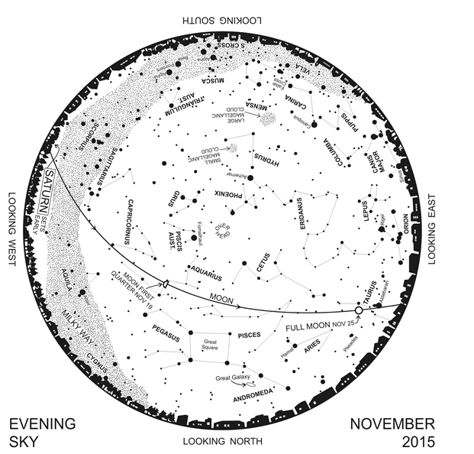

Johannesburg Branch of the Astronomy Society of South Africa
Meetings are held on the second Wednesday of each month, excluding December at the Johannesburg Observatory, 18A Gill Street, Observatory, Johannesburg, at 19:30. Visitors are welcome to attend all our meetings. The Centre has two medium-sized observatories housing four telescopes, and has the use of the 26.5-inch Innes Telescope. Viewing evenings which are open to the public are conducted on the Fridays when the Moon is nearest 1st and 3rd Quarter. Contact astronomersinc@hotmail.co.za for more information about open night tours of the Johannesburg Observatory

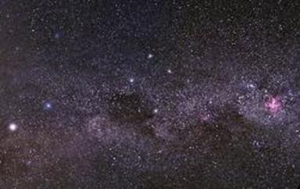 | We are conscious of our place in the cosmos.  We remember moments of wonder,  sensing the infinite world of space,  connecting with endless networks in time  and feeling the mystery of the moment.  We remember and rejoice.  Thank you, God, for making us aware  of our special place in your web of creation.

