JAEI ENVIRONMENTAL CORNER

Celebrating a Season of Creation
Biodiversity – “Our Sister, Mother Earth”

(Taken from Season of Creation: Book 3)
Praised be You my Lord with all Your creatures,
Especially Sir Brother Sun, who is the day through whom You give us light.
And he is beautiful and radiant with great splendour.
Of You Most High, he bears the likeness.
Praised be You, my Lord, through Sister Moon and the stars.
In the heavens You have made them bright, precious and fair.
Praised be You my Lord through our Sister, Mother Earth!
Who sustains and governs us, producing varied fruits with coloured flowers and herbs!
Praise and bless my Lord, and give thanks to the Lord, and serve the Lord with great humility.

The final Sunday in the Season of Creation is 4th October which is also the Feast Day of St Francis of Assisi as well as World Animal Day
It is a day to celebrate animal life in all is forms and humankind's relationship with the animal kingdom. The day is celebrated annually. The World Animal day was originally started at a convention of ecologists, 1931 in Florence. Since October 4th is the Feast Day of St Francis of Assisi, the patron saint of animals and the environment, this date was chosen to celebrate the World Animal Day.
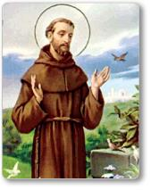
So who was St Francis? Francis was born in the 12th Century, the son of a wealthy merchant family in Italy. In his youth, he was known for his extravagant, materialistic lifestyle. In his early twenties as he witnessed poverty and disease he began to hear a call from God. In a time of prayer he heard a voice say: “Go, Francis and repair my house which is falling into ruin.” He gave up all he had and began to repair local churches in ruins. But he realized that God’s house actually meant God’s household – the whole of Mother Earth. He saw that God’s household (oikoumene) from which the root ‘eco’ comes which we use in words like ecology, economics) was not just buildings but included the poor and all the creatures of the Earth.
Francis gave up all he had and shared his home with the moon, sun, stars, water, fire, flowers, children, elders, birds, and even death. All those who shared this home he called brother and sister, and he saw them as all part of God’s family. When he came upon a cornfield or a spring of water, he would preach to them and encourage Francis gave up all he had and shared his home with the moon, sun, stars, water, fire, flowers, children, elders, birds, and even death. All those who shared this home he called brother and sister, and he saw them as all part of God’s family. When he came upon a cornfield or a spring of water, he would preach to them and encourage them to sing out in praise to God.
The Choir of All Creation
“As South Africans we sing when we are happy and we also sing when we are sad to make ourselves feel better” (day of prayer and reflection for the passing of former president Nelson Mandela). Music is in our souls, our Sunday services almost always involve worship, and this may be led by a choir, a band or an orchestra! In Biblical times too, the psalms were led by a choir. A group of singers from a family or clan would serve as mouthpieces for the whole community – expressing to God the community’s joy, pain or fear.
Psalm 148 radically broadens the circle of who is included in this choir or family. In each line, singers reach out past the boundaries that divide them. Not only the politically important, the wealthy, kings, princes and rulers must sing, but young men and women those without power or influence join in also. Both young and old are included, both women and men. But the Psalm goes beyond human beings, other parts of creation are invite to join the song:
“You heavens; you angels and hosts; you sun,
moon, and shining stars;
you highest heavens and waters above the
heavens; hey, you sea monsters and all deeps; you
fire and hail, snow and frost, stormy wind; you
mountains and hills; you fruit trees and all cedars
over there; you wild animals and all cattle, creeping
things and flying birds – all of you together, join in
this ecstatic chorus of praise to our Creator” v 3-12
This is the image of an amazing, diverse, praise chorus encompassing the whole web of life – a chorus, a family, that can and should praise God. For God created all parts of the cosmos with love. It is not only the human family that is called to bear witness. A hymn of praise that only includes humans would be a choir without harmony.
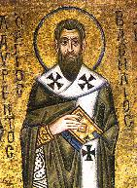
Tanya Barnett www.webofcreation.org/worship/260-the-choirof-al-creation-by-tanya-barnett
St. Basil the Great’s 4th Century contrition laments this sad choir: “O God, enlarge within us the sense of fellowship with all living things, our brothers the animals [and all creatures] to whom thou gavest the earth as their home in common with us. We remember with shame that in the past we have exercised the high dominion of humans with ruthless cruelty so that the voice of the earth, which should have gone up to thee in song, has been a groan of travail. May we realize that all creatures live not for us alone but for themselves and for thee, and that they love the sweetness of life.”
How tragic would St Basil feel with the current rates of extinction?

Extinction Fact sheet
It is very hard to know exactly how many species are becoming extinct because we don’t actually know how many there are! Surprisingly, scientists have a better understanding of how many stars there are in the galaxy than how many species there are on Earth. However, the rapid loss of species we are seeing today is estimated by experts to be between 1,000 and 10,000 times higher than the natural extinction rate (without human intervention).
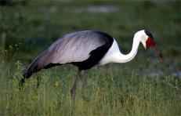
Wattled Crane – critically endangered because of habitat loss
These experts calculate that between 0.01 and 0.1% of all species will become extinct each year. If the low estimate of the number of species out there is true - i.e. that there are around 2 million different species on our planet - then that means between 200 and 2,000 extinctions occur every year. But if the upper estimate of species numbers is true - that there are 100 million different species co-existing with us on our planet - then between 10,000 and 100,000 species are becoming extinct each year.
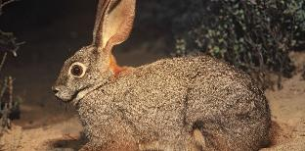
Critically endangered – Riverine Rabbit (13th most endangered animal in the world – to South Africa’s shame!)
Every species loss diminishes the diversity of life on Earth with untold consequences for the web of life.
And the most fragile part of this web of life surely includes the poor of the earth: those people whose well-being is most immediately and directly connected to the well-being of creation. This is the heart-breaking news: we are, knowingly and unknowingly, silencing the song of Creation.
wwf.panda.org/about_our_earth/biodiversity/biodiversity
With such loss of biodiversity, we miss out on hearing the unique expressions of what God is doing through creation.
Romans 1:20 “Ever since the creation of the world, God’s eternal power and divine nature, invisible though they are, have been understood and seen through the things God has made.”
It is difficult to hear the choir of all creation in its fullness today. With so much environmental degradation, and our separation from the natural world, our stressed and hectic lives, we do not hear the song of God.
The Second Book of God
“God writes the Gospel, not in the Bible alone, but also on trees, and in the flowers and clouds and stars.” Martin Luther
Theologians have traditionally categorized the Bible and nature as “two books,” which when read side by side combine to reveal the God of creation. The first book, the Scriptures of the Old and New Testament, is called “special revelation.”
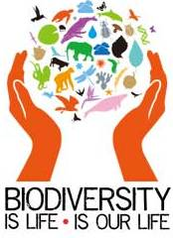
The Scriptures are special, in part, because if God had not chosen human writers who were inspired by the Spirit of truth to disclose this unique and specific knowledge, we would not be aware of it.
The second of God’s two revelations is the book of nature, termed “general revelation.” This is the record of our Creator that is revealed in the natural world around us. We call it a general revelation because it has been generally available to people throughout all the ages. It showcases the handiwork of God in the creation, and records His direct and indirect actions on the earth and in human history.
The apostle Paul wrote, “Since the creation of the world [the Creator’s] invisible attributes are clearly seen, being understood by the things that are made, even His eternal power and Godhead” (Rom. 1:20).
The Hebrew author of Psalm 19 expressed a similar observation when he wrote, “The heavens declare the glory of God; and the firmament shows His handiwork. Day unto day utters speech, and night unto night reveals knowledge. There is no speech nor language where their voice is not heard. Their line has gone out through all the earth, and their words to the end of the world” (vv.1-4).
wonderofcreation.org/resources/gods-two-books-natureand-the-bible
Do we take time to listen to God in trees, animals, flowers and stars? God is speaking, but are we listening?

A PRAYER OF ST AIDAN
Leave me alone with God as much as may be.
As the tide draws the waters close in upon the shore,
Make me an island, set apart,
alone with you, God, holy to you.
Then with the turning of the tide
prepare me to carry your presence to the busy world beyond,
the world that rushes in on metill the waters come again and fold me back to you.

As the air sings with songs of glory,
as the water flashes with the silver of creation,
as the forests bloom with leaves for the healing of the nations,
so may God’s light and love
fill our hearts and souls and minds
seasonofcreation.com Land Sunday

COLLECT
Lord of all life
your care is known through the sparrow and the hairs of our head:
remind us of your goodness in creation and our place within it
that our voice may resound with every creature
in heaven and on earth and under the earth and in the sea
proclaiming honour and glory to the Lamb,
through Jesus Christ who reigns with you and the Holy Spirit
one God now and forever. Amen

May none of God’s wonderful works keep silence,
night or morning.
bright stars, high mountains, the depths of the seas,
sources of rushing rivers:
may all these break into song as we sing
to Father, Son and Holy Spirit.
May all the angels in the heavens reply: Amen, amen
Power praise and honour, eternal glory to God the only
Giver of grace Amen, Amen, Amen
Third century hymn
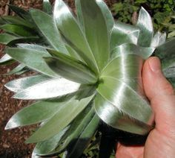

God, our Creator, whose glory fills all things, help us to discern your presence among us and our kin in creation, especially in the soil, in the fields, and on the land. Help us to empathize with your creatures who are suffering and to serve you as agents for healing the land. In the name of Christ, who reconciles and restores all things in creation. Amen.

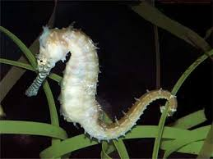

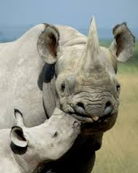

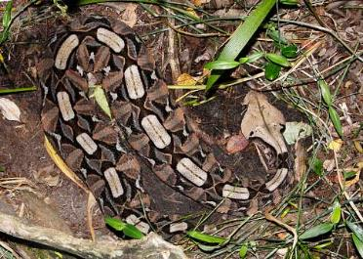
Christ, we come into your presence
to worship in this sanctuary called Earth, a planet pulsating with your presence,
a presence quivering in the forests,
a presence vibrating in the land,
a presence pulsating in the wilderness, a presence shimmering in the rivers.
We regret that we have became alienated from Earth, and treated this garden planet
as a beast to be tamed,
as a domain to be dominated,
and as a place to be ruled for our gain.
We remember and confess how we have violated and polluted the lands of our garden
We are sorry.
We have killed living soils with chemicals,
we have turned fertile fields into lifeless plains, we have cleared rich lands of wildlife.
We are sorry. We are sorry.
seasonofcreation.com Forest Sunday

