JAEI ENVIRONMENTAL CORNER
Wangari Maathai
the first African woman to win the Nobel Peace Prize

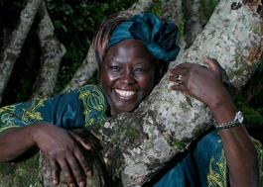
In this era of increased concern about the ecological crisis unfolding throughout the world, many faithful including Christians are responding by preaching and teaching on environmental issues and getting involved in a variety of campaigns. Often spiritual leaders are without environmental knowledge, while many environmental campaigns lack spiritual inspiration.
The book Replenishing the Earth: Spiritual Values for Healing Ourselves and the World, by Nobel Peace Prize winner, the late Wangari Maathai, is an important book for anyone interested in the environment or eco-spiritualism, or both.
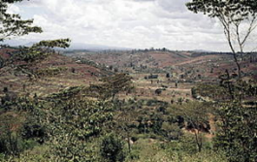
Wangari Maathai grew up in rural Kenya when trees and rivers were healthy and plentiful. She was distressed at the desertification of Kenya, how trees were being chopped down to sell charcoal to foreign companies, how people could no longer grow their food and their children were starving. She wanted to find a way to reverse this in order to support women and their families. So she started the Green Belt Movement in 1977.*
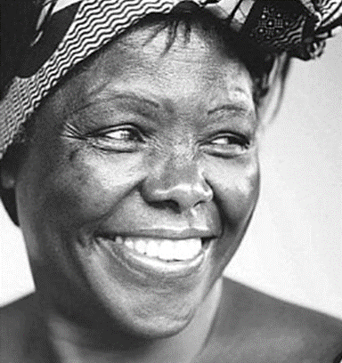
One programme was to plant indigenous trees and remove the alien invasive trees like the Eucalyptus trees that the British settlers had imported from Australia to dry up rivers in order to plant cash crops like coffee and tea. As the women, including Wangari, planted the indigenous trees and felt the soil with their hands, something amazing happened. They felt an incredible joy and reconnection with the earth. Slowly and surely the movement grew. The earth started replenishing, rivers sprung back to life, trees began to bear fruit, thousands of communities had hope again. Wangari said it was her work with the environment that inspired her faith and not the other way around. She believed if we can find ways to connect and replenish the Earth, we will feel closer to God. Sadly she passed away but her legacy continues. To date the Green Belt Movement has planted over 51 million trees in Kenya!**
As a committed Christian who was well-versed in many religions, she returns to the creation stories for inspiration. Since creation is so important to our faith, this book is helpful for anyone who cares about life and the future of humankind. Wangari believes that rededicating ourselves to spiritual values of love for the environment, self-betterment, gratitude, respect and commitment to service, we can help heal ourselves and the earth.
Wangari’s story can inspire us to find ways to reconnect and replenish the Earth. This can ignite a lifelong passion for God and God’s Creation that we can share as we build God’s Kingdom today. Why not plant an indigenous or fruit tree in your parish today during September, which is dedicated to Creation.
“Through experience and observation, I have come to realize that the physical destruction of the earth extends to humanity, too. If we live in an environment that’s wounded – where the water is polluted, the air filled with soot and fumes, the food is contaminated with heavy metals and plastic residues or the soil is practically dust – it hurts us, chipping away at our health and creating injuries at a physical, psychological and spiritual level. In degrading the environment, therefore, we degrade ourselves and all humankind. The reverse is also true. In the process of helping the earth to heal, we help ourselves.” (Maathai 2010:16-17.)
Wangari illustrates here involvement in acting against climate change through a simple story. She challenges us all to be involved and do our bit:
One day a terrible fire broke out in a forest - a huge woodlands was suddenly engulfed by a raging wild fire. Frightened, all the animals fled their homes and ran out of the forest. As they came to the edge of a stream they stopped to watch the fire and they were feeling very discouraged and powerless. They were all bemoaning the destruction of their homes. Every one of them thought there was nothing they could do about the fire, except for one little hummingbird.
This particular hummingbird decided it would do something. It swooped into the stream and picked up a few drops of water and went into the forest and put them on the fire. Then it went back to the stream and did it again, and it kept going back, again and again and again. All the other animals watched in disbelief; some tried to discourage the hummingbird with comments like, "Don't bother, it is too much, you are too little, your wings will burn, your beak is too tiny, it’s only a drop, you can't put out this fire."
And as the animals stood around disparaging the little bird’s efforts, the bird noticed how hopeless and forlorn they looked. Then one of the animals shouted out and challenged the hummingbird in a mocking voice, "What do you think you are doing?" And the hummingbird, without wasting time or losing a beat, looked back and said, "I am doing what I can."
Like the hummingbird, we each must do what we can.
Sadly, on 25th September, 2011, at the age of 71, Wangari passed away after a long battle with ovarian cancer. Kenya, and indeed the world-wide community lost one of their foremost heroines.

References
*(www.greenbeltmovement.org)
**Maathai, W. 2010. Replenishing the Earth: Spiritual Values for Healing Ourselves and the World. London: Doubleday

