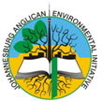
JAEI ENVIRONMENTAL CORNER

Celebrating a Season of Creation
Water - The source of life

(Taken from Season of Creation: Book 1)

At the beginning , one river flows out of Eden, to become the watershed that cradles civilisation (Gen 2:10-14) At the very end, a cosmic echo declares the invitation of the One who is called the Alpha and Omega, “Let everyone who is thirsty come. Let anyone who wishes take the water of life as a gift.” - (Rev22:17)

From start to finish in Bible history fresh water bubbles, gushes, gurgles, flows, floods, rain-bows the sky, or suddenly dries up. Then it pours out of God’s upper chambers all over again, to nurture, sustain, wash, cleanse, baptize, heal or tempest-toss the heroes and heroines of God’s story, towards his good ending. Clean drinking water is closely linked to the mystery of the Bible’s theme of mission.” (* Goddard. A. Inaugural conference of A Rocha.)
“To him who is thirsty I will give to drink without cost, from the spring of the water of life.” - (Rev 21:6)

“And God said: ‘Let the waters bring forth swarms of living creatures, and let birds fly above the earth across the dome of the sky’. So God created the great sea monsters and every living creature that moves, of every kind, with which the waters swarm, and every winged bird of every kind. And God saw that it was good. God blessed them, saying ‘be fruitful and multiply and fill the waters in the seas and let birds multiply on the earth”’ - (Gen 1:20-22)

We have been given universal laws. The Roman Catholic Church talks of ‘The Natural Law’. Even for those who don‘t accept the concept of God, there are laws of the universe upon which life is dependent. These laws include living in harmony, in balance and respecting the rhythms of life.
Life on this planet is a self-sustaining process: life and the diversity thereof, maintains life. Everything is inter-related. If one component of life is destroyed, the other parts come under increasing pressure. The more we destroy biodiversity, the more we threaten a sustainable future.
An essential part of life is, of course, water. Were it not for water, there would be no life on this planet as we know it. We hear it in the creation stories:

“Now the earth was formless and void, darkness was over the surface of the deep, and the Spirit of God was hovering over the waters.” - (Genesis 1:2)
“Streams came up from the earth and watered the whole surface of the ground.” - (Genesis 2:6)

Earth is the only planet in our solar system where water is found in all three states: solid, liquid and gas. In particular it is the only planet where water is found in a liquid state, the only planet with drinkable water. Water is essential to all forms of life on earth. The religions of the world recognise the sacredness of water. They see water as a gift from God. They know it is essential to life. They know that we, and all plants and animals are dependent on water. They know therefore that we and all living beings have a right to water.

“The river flowed into the sea and made its waters wholesome. Wherever the river flows, all living creatures teeming in it will live.” - (Ezekiel 47: 8,9)
Water has a significant scriptural meaning. Jesus said to the Samaritan woman: “The water I will give him will become in him a spring of water welling up to eternal life.” - (John 4:14)
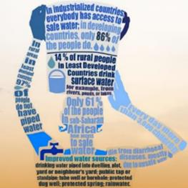
The World Health Organisation estimates that 1.1 billion people, (approximately 20% of the global communities) live without adequate access to water and more than 5 million people die each year of inadequate water or water borne diseases. As Christians therefore we should view with the utmost concern the commodification of water (treating water as a mere commodity to be sold at a profit.) Nowhere should people be denied the right to adequate water because they cannot pay for it. Nowhere should people profit from water through denying others access to it. And there is the often neglected aspect that, for the rest of living creation, survival is being threatened not only by the loss of habitat but by being denied access to life-giving water. All of life must be taken into consideration because biodiversity is essential for the ongoing sustainability of life.
You might ask, “But how do we place a value on this all-important source of life?” This is important because without placing a value on it we continue to abuse, misuse, pollute and waste this essential of life. It is therefore fundamentally important that people have access to adequate clean water to meet their basic needs, and that industry and agri-business pay for the privilege of using large quantities. An example can be given from South Africa: Every household is entitled to a free basic water allowance while the timber industry must pay for water that plantations consume.
All people have the right to water. An essential for all governments should be to ensure adequate quantity and quality for its people. Government is understood as being the people’s representative at all levels. Every effort should be made to ensure that communities should participate in the management of their own resources. More power should be in the hands of the people if we are to find peace on this finite planet. Justice, democracy and equitable access to natural resources are prerequisites for peace – without them, we will not find peace. We cannot hand over to commercial interests or multinational corporations what should be under the control of local communities, particularly at this critical time when climate change is undermining livelihoods and food security amongst small scale farmers in many parts of the developing world. Currently, our life support systems – our water, our air and our soil – are being threatened because of the domination of commercial interests.
The situation in South Africa
South Africa is one of the 20 driest countries in the world. Our annual rainfall is less than 500mm. 72% of our water is used for agriculture, 11% for industry and 17% for domestic use.
- 12% of South Africans do not yet have access to drinking water.
- 45% do not yet have access to adequate Sanitation
“Then the angel showed me the river of the water of life, bright as a crystal, flowing from the throne of God and of the Lamb through the middle of the street of the city. On either side of the river is the tree of life with its twelve kinds of fruit, producing its fruit each month, or the leaves of the tree are for the healing of the nations”. - (Rev 22:1-2)
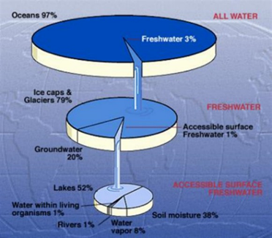
Water in liquid form, is the essence of all life. Our planet is the only one that has it. 97% of the earth’s water is sea water. Two thirds of the remaining fresh water is locked up in polar and glacial ice. South Africa is a water scarce country. We get only half the world’s average annual rainfall, 60% of which falls in 20% of the country. Climate change is causing more intense weather events like hurricanes, tornados, hail and super storms, droughts and floods. The growing unpredictability of rainfall patterns makes water management a challenge. While suburban dwellers in South Africa have reliable supplies of good quality water, this is not the norm for people living in townships, informal settlements and rural areas. (12% of South Africans do not have reasonable access to safe drinking water and 45% do not have adequate sanitation). Future water scarcity threatens our long term political, social, economic and ecological security and sustainability.
It is predicted that at our present rate of consumption, SA will run out of water between 2020 and 2040. We can attribute the reduction of water quantity and quality to timber plantations and unsustainable commercial agriculture, industry & mining, alien invasive plants, land degradation, climate change, pollution (especially of ground water by the mining industry), population growth and rising affluence.
There is however a deep underlying source of concern: the prevailing economic system is reducing public and community control over water to a commercial good. The growing global trend to privatize water is threatening to deprive the poor of access to what should be a basic human right. People of faith should seek to ensure that all and that all life has access to water.
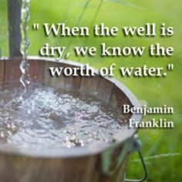

Get Creative!
- Move the baptismal font to the centre of the church if possible, or a large bowl of water. Invite people to bring a container of water from their different communities and pour them into the bowl. Then say a prayer to bless our communities and the water in them.
- Rather than using incense on this particular Sunday, sprinkle the altar with holy water.

What you can do to save water (if you have access to municipal water)
Simple water conservation measures can reduce consumption by 30 to 40% without discomfort:
- Repair leaking taps. Report water leaks and vandalism to the municipality.
- Save water – bathing uses 150 litres, showering 30 and washing in a basin only 10!
- Reduce toilet flush volume: put a filled 2lt plastic bottle in the cistern or install a ‘dual-flush’ system.
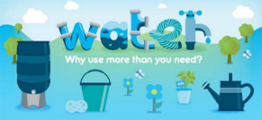
- Boil only as much water as you need.
- Install tap aerators to reduce the water
- Don’t rinse anything under running water – turn tap off when brushing teeth and washing dishes.
- Collect cold water while waiting for the hot to arrive from the geyser.
- Make sure washing machines and dishwashers are full before running a load.
- Install rainwater tanks - collect water from roof run-off.
- Plant water-wise plants & mulch (cover with dry plant material or wood bark) to reduce evaporation. Avoid watering in wind or during the heat of the day, water plants deeply but less often & use ‘grey water’ from bathing.
- Cover swimming pools to reduce evaporation.
- Brush outside areas with a broom & wash cars with a bucket rather than using a hose.
- Don’t throw oil, paint, medicines, chemicals & poisons into sewers and storm water systems.
- Get your church involved in a river clean up scheme and wetland conservation.
- Bore-holes often tap water from ancient aquifers which may take thousands of years to be replenished. Bore-hole water should not be ‘wasted’ on suburban gardens. If it is to be utilized, this water should be kept for circumstances of dire need.
- If you see water being wasted – do something!!

Prayer
Creator God, you brought order out of chaos transforming and separating the raging ocean into earth, sky and seas, filling them with living creatures; then you created human beings and put us in charge of your creation. Show us how to use your creativity today when the delicate balance of nature is under threat.
Lord Jesus, Living Water, create in each one of us a pool of peace, a deep well of healing that can transform bitterness to love
- impatience to patience
- irritation to tolerance
- rejection to acceptance
- and inadequacy to confidence in our own ability,
Holy Spirit, powerful wind moving across the waters; enable us to recognize in ourselves; our preoccupation with our own needs and desires; our apathy and ignorance in acknowledging and understanding the needs and desires of others.
Empower us to transform this recognition into motivation, to seek equality, justice and peace for all people throughout our world. Amen.

