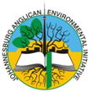
JAEI ENVIRONMENTAL CORNER

Celebrating a Season of Creation
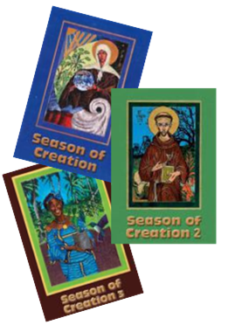
The annual celebration of a six week Season of Creation has become increasingly common in churches throughout the world. Within the Orthodox tradition 1 September has long been regarded as the first Day of Creation, and over a number of years there have been calls by church bodies for an annual six week celebration of a Season of Creation, beginning on the Sunday nearest 1 September. For us in the South (geographically!) this period coincides symbolically with the start of spring.
We are indeed fortunate to have three wonderful publications of “Season of Creation, Books, 1, 2 & 3 to inspire us in the celebration of this truly wonderful time of the year. These publications are available at R30 per copy, or free to download at www.jaei.org.za .
There is also a wonderful Sunday School Season of Creation Programme, which has been circulated to all Parishes, but should you have not received a copy, do contact the Diocesan Office or contact Chairperson of the Children’s Ministry Team - Catherine Plint at cath.plint@gmail.com .

So why Season of Creation?

In commending this booklet Archbishop Thabo Makgoba wrote (on the back page):
“We worship a creator God. The more we learn about the natural world, the more wonderful we discover it to be. There is a real danger that with all our modern technical discoveries we lose sight of the magnificence and intricacy of creation. We are discovering that creation is seriously under threat.
That there is life on this planet is a miracle in itself. It is the most serious of sins that we humans are threatening this life. For too long we have selfishly misused and abused God‟s mandate to “have dominion over” creation (Genesis 1:28). Now is the time to recognize that we have a responsibility to God to care for this intricate web of life, acknowledging that “The Earth is the Lord’s and all that is in it” (Psalm 24)”.
Here are some suggestions on themes and readings
WEEK 1: GOD AND CREATION
Begin the Season by focussing on the beauty of Creation, and God’s presence in it (as well as beyond it). .. But look at the threats to it as well, especially from the changing climate which can lead to erratic weather patterns (with the increase of flooding and droughts), the extinction of species, and the spread of diseases. Also the unprecedented loss of biodiversity.
- Exodus 19:1-9 Wilderness, mountains, eagles, „the whole earth is mine‟
- Psalm 104: 14-26 Many elements of creation
- Acts 17: 22-28 God who made the world and everything in it
- Matthew 13: 31& 32 God‟s kingdom like the processes of nature

WEEK 2: - FORESTS
The first week of September is National Arbour Week. While planting trees helps offset carbon emissions, it is vitally important that we preserve forests. Forests provide a habitat for animals and other creatures as well as serving as a source of food and medicine for people. We may think that the rainforests have nothing to do with us, after all they are up “there” somewhere around the Equator – how can we affect them?!! - However, our local actions do indeed affect those rain forests – the “the lungs” of the planet!
- Ezekiel 34: 25-31 The trees of the field shall yield their fruit
- Psalm 96 The trees of the forest sing for joy
- Revelation 22:1-7 Leaves of the tree for the healing of the nations
- Luke 13: 6-9 Parable of the fig tree
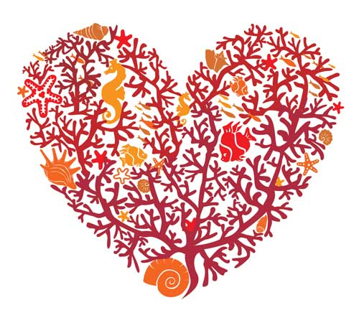
WEEK 3:– OCEANS
17 September is International Coastal Clean-up day.
16 September is the International Day for the Preservation of the Ozone Layer & Recycling Day SA.
12-17 September is National Clean up Week.]
Again – why should we worry about the Oceans? – nowhere near Gauteng! … and again … what we do locally does affect our Oceans, whether we like it or not!
As well as sustaining life in abundance, they provide a livelihood for many. Our seas play an important role in the absorption of carbon dioxide and the consequent stabilization of our climate. Did you know that approximately 70% of the oxygen we breathe every day comes from the Ocean? (from tiny ocean plants - called phytoplankton - that live near the water's surface and drift with the currents.)
- Genesis 1: 9 & 10 Creation story
- Psalm 95 The sea is God’s
- Acts 4: 23 – 26 God made the heaven, the earth and the sea
- Mark: 6: 47-52 Jesus and the disciples on the sea
WEEK 4: - PEACE WITH CREATION
21 September is International Peace Day.
Preservation of Creation and reversing the effects of climate change require the establishment of God’s peace – shalom – which implies harmonious human relationships, respect for ecological integrity and a just economy.
- Isaiah 61: 1-11 Freedom and restoration of all
- Psalm 85: 8-13 Righteousness and peace kiss each other
- Romans 12: 14-21 Live peaceably with all
- Matthew 5: 1-11 Blessed are the peacemakers
WEEK 5: - HERITAGE
24 September is Heritage Day.
This week we celebrate South Africa’s rich biodiversity as well as its wealth in human culture and language.
- Deuteronomy 8:1-15 A Land of richness
- Psalm 150 Celebration (with a diversity of instruments!)
- Acts 2:1-11 The Gift of different languages
- Luke 10: 25-37 Compassion across cultures
WEEK 6:– STEWARDSHIP OF THE EARTH
October is stewardship month in many Parishes in the Diocese – and what better focus on than the stewardship of all the resources of the earth. On 4 October we celebrate St Francis Day, when we recall not only Francis‟ familiarity with animals and birds but also his relationship with all of creation - “brother sun, sister moon”.
Have a wonderful Season of Creation!

The Canticle of Creation (by Saint Francis of Assisi)

O Most High, all-powerful, good Lord God,
to you belong praise, glory, honour and all blessing.
Be praised, my Lord, for all your creation
and especially for our Brother Sun,
who brings us the day and the light;
he is strong and shines magnificently.
O Lord, we think of you when we look at him.
Be praised, my Lord, for Sister Moon,
and for the stars
which you have set shining and lovely in the heavens.
Be praised, my Lord,
for our Brothers Wind and Air and every kind of weather
by which you, Lord,
uphold life in all your creatures.
Be praised, my Lord, for Sister Water,
who is very useful to us,
and humble and precious and pure.
Be praised, my Lord, for Brother Fire,
through whom you give us light in the darkness:
he is bright and lively and strong.
Be praised, my Lord,
for Sister Earth, our Mother,
who nourishes us and sustains us,
bringing forth
fruits and vegetables of many kinds
and flowers of many colours.
Be praised, my Lord,
for those who forgive for love of you;
and for those
who bear sickness and weakness
in peace and patience
- you will grant them a crown.
Be praised, my Lord, for our Sister Death,
whom we must all face.
I praise and bless you, Lord,
and I give thanks to you,
and I will serve you in all humility.

