JAEI ENVIRONMENTAL CORNER
Bottled water, anyone? - No thanks!
Bottled Water Facts

Brief history of bottled water
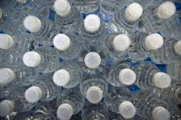
Bottled water first became commercially available in France. In 1829, the Evian water company was set up to begin selling mineral water. Other countries soon followed suit and began selling their spring water e.g. in 1851 England introduced its bottled water, Malvern at the Great Exhibition in London; in 1899 Italy began its bottled mineral water sales through the San Pellegrino brand. By 1908, San Pellegrino was exported across the globe.
Globally, the rate of consumption of bottled water is rising at about 12 percent per year, with annual spending estimated at around $35 billion.
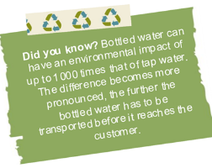
Over the last few decades, big beverage companies including Coca-Cola, Pepsi and Nestlé have heavily invested in marketing strategies from introducing appealing flavours and vitamin and mineral supplements, to altering the public’s perception of the quality of tap water – all to secure a hold on the burgeoning bottled water market.
Is bottled water cleaner than tap water?
In general, the public’s perception is that bottled water is cleaner, but numerous tests and reports have found that in most cases, bottled water and tap water were of the same quality. In many countries, there are very few, or no regulations tied to monitoring the quality of bottled water. In some instances, bottled water was been found to contain more contaminants than tap water.
Which is safer – bottled or tap?
The public’s perception of bottled water (largely attributed to marketing campaigns) is generally that it is safer to drink than tap water. While drinking bottled water is generally encouraged in areas where tap water may be contaminated, it is far less expensive to produce ‘clean and safe-to-drink’ water by boiling or filtering local water.
Bottled versus tap – cost comparison
Bottled water can cost anywhere from 500 times to 1000 times more than tap water. In South Africa a 1000 litres of tap water costs ±R16, whereas bottled water can cost as much as R13 200 per 1000 litres!
Environmental impacts of bottled water vs. tap water For every 1000L of tap water consumed, 1.78 kg CO2e is generated. For every 1000L of bottled water consumed, 320kg CO2e is generated. A litre of bottled mineral water generates up to 600 times more carbon dioxide than a litre of tap water. Even the best performing bottled water scenario, which uses and recycles a light-weight bottle, has global warming effects 46 times greater than the best performing tap water scenario.

Where does our water come from?
Most of our piped water comes from dams, underground sources and natural springs in the mountains or from boreholes nearby. And in most cases, the water sold as bottled water comes from the same sources.

How much tap water is needed to produce bottled water?
It requires about 3 times as much tap water to make the bottle as it does to fill it. Energy footprint of bottled water
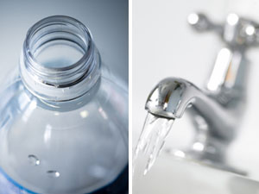
The energy footprint of bottled water has two major components: the manufacturing of the bottle itself and the transport. Recycling plastic or glass reduces energy consumption by about 20-25% and greenhouse-gas emissions by about 15%. Waste from bottled water PETCO – PET plastic recycling South Africa (http://www.petco.co.za/) - aims to increase the rate of PET-recycling in the country from 34 to 38 percent (± 34,580 tonnes) this year.
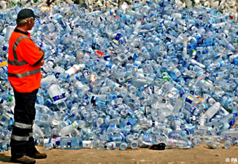
In other words, in this year alone 56,000 tonnes of PET will be dumped at landfill sites, where they will remain for some 10,000 years. In some instances the bottles do not end up in the nearby landfill, instead the bottles are exported and dumped in landfills overseas or dumped into the oceans.

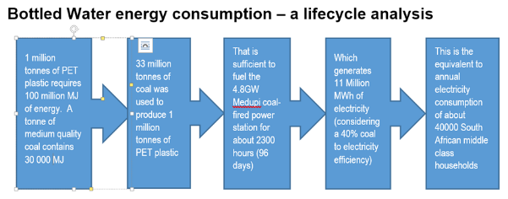
What can we do?
- Say no to bottled water at home, at school, on the go, and in restaurants – wherever you have access to clean and safe tap water.
- Buy a reusable bottle and keep it filled for when you’re on the road.
- Install a water filtration system if you don’t like the taste of tap water. Avoid refrigeration of tapped water. Chlorine (from the treatment process) evaporates at room temperature.
- Install public water fountains in schools, offices, sports stadiums and parks.
- Opt for tap water in jugs in communities, restaurants, at work, social functions and promote the serving of tap water.
- Develop and implement policy restrictions on bottled water and lobby for prices that reflect the true cost of bottled water.

Also read
- Understanding the energy demand of bottled water -
http://www.eeweek.org/assets/files/water_and_energy/
- Bottled water: understanding a social phenomenon -
http://assets.panda.org/downloads/bottled_water.pdf

Acknowledgments - www.90x2030.org.za

Intercessory prayer
You will need: a glass of clean water, a glass of salty water, a bottle commercial bottled water and an empty glass. You might like to play soft music in the background.
Leader | Let us pray for the whole universe. (Hold up the glass of clean water.) Lord let this glass of clean water remind us of the available sources of fresh drinking water. Help us to protect the gift of water and utilise it with the spirit of sanctity and responsibility. May our lives be so balanced that greed makes way for need and the tendency to waste makes way for a commitment to save.
All | Fountain of life, wash us clean from greed and sin
Leader | (Hold up the glass of salty water.) Let this glass of salty water remind us of the tears of those whose lives have been threatened by the excessive salination of their water resources. Let those who contribute to the rising sea levels shed tears of repentance and learn to lead a simple life so that others can ‘simply live’
All | Creator of new life, transform us so that we may be channels of life.
Leader | (Hold up a bottled water.) God of justice, we pray for all those who are resisting multinational corporations and developmental processes which plunder our natural resources and threaten the livelihood of millions. We pray for all organisations involved in the preservation of water, and with it, your gift of life. Help, guide and sustain them in their endeavours.
All | God of justice strengthen those who seek to preserve your creation.
Leader | (Hold up the empty glass.) Lord, we pray for all communities involved in the issues of water justice. Give us compassion to walk with those who lack the water of life. Help us to empty ourselves of prejudice and fill us with a vision of solidarity and fellowship so that we can work together in conserving the Gift of water.
All | God of justice give us your vision.
Leader | Lord, we pray for the universal church and its mission and vision. Inspire us to work towards water justice. Transform our lives so that we may be channels of justice - not just in what we preach, but in our daily practice. Let your churches be role models within our communities in conserving water and preserving life in all its fullness. Bring churches together to work in unity so that justice will prevail and water will be available for our generation and future generations.
All | God of hope make us instruments of hope.
Leader | We bring these prayers to you in the name of Christ, our Saviour,
All | Amen.

(Taken from Season of Creation)

