
JAEI ENVIRONMENTAL CORNER
Carbon Fast for Climate – Eating & Moving!
(Week 1 & 2)



Eating (22 – 28 February)
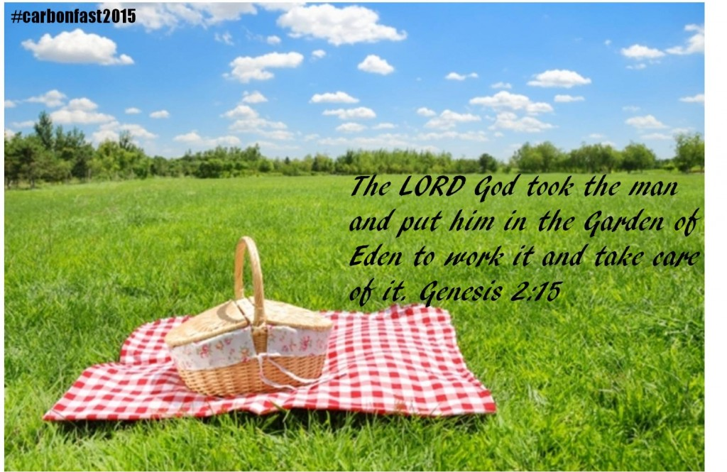 |  |  |  |  | Sunday 22nd February  The Lord God took the man and put him in the Garden of Eden to work it and take care of it.  Genesis 2:15
Before God gave the human race the ten commandments, before God told us to go and make disciples, he gave us a simple commandment - “Take care of my Earth”
We have not done a good job of caring for God’s Earth. According the Living Planet Index, Biodiversity has declined by more than a quarter in the last 35 years. ….And that’s not good news!
Globally, we now require the equivalent of 1.4 planets to support our lifestyles. This is humanity’s current Ecological Footprint – the demand people place upon the natural world.
We are polluting our rivers and seas, creating piles of waste and toxic chemicals. It is time for us to change. Today the challenge is this – how can I help my Church to be an Earthkeeping community?
This week we are looking at food. How does my church cater? Where do we buy our food, is it local or shipped in from far away. Do we use free range chicken or factory farmed? What happens to leftover food? Do we use Styrofoam or do we wash up?
Styrofoam (polystyrene) Non-Biodegradable
Styrofoam appears to last forever, as it is resistant to photolysis, or the breaking down of materials by photons originating from a light source. This, combined with the fact that Styrofoam is lightweight and therefore floats, means that over time a great deal of polystyrene has accumulated along coasts and waterways around the world. It is now considered the main component of marine debris.
Food Contamination
When Styrofoam containers are used for food, chemicals can leach into the food, affecting human health and the reproductive systems. This is accentuated if people reheat the food while still in the container.
Let us be Earthkeepers, starting in our Church Kitchen!
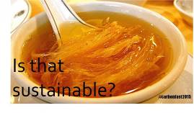 |  | Monday 23 February  Meat Free Monday: Boycott unsustainable products, do not buy products from endangered animals. Know the best and worst products  In his hand is the life of every living thing and the breath of every human being.” [Job 12:10]
All living beings are all precious to God – not just humans. “ … even the hairs of your head are all counted.” And, likewise, not even a single sparrow “is forgotten in God’s sight.” [Luke 9:6-7] “Your righteousness is like the mighty mountains, your judgments are like the great deep; you save humans and animals alike, O Lord.” [Psalm 36:6]
Given God’s great love for all creatures, we need to reflect on our practice of eating meat farmed in factory farms. Conditions in these operations unlike organic farms are unhealthy and cruel. Animals who are intended by nature to forage for food are fed corn and soybeans instead of grass. To prevent the inevitable spread of disease from stress, overcrowding and lack of vitamin D, animals are fed a steady diet of antibiotics. Animals often develop antibiotic-resistant bacteria in their guts, which contaminates the food chain and poses a threat to human health.
Pigs: Sows spend each pregnancy confined to a sow stall only slightly larger than her body, making it impossible for her to lie down comfortably. The slatted flooring of a sow stall causes foot injuries. Sow stalls have been banned in Europe. Shortly before piglets are born, sows are moved to ‘farrowing crates’ where the piglets will be nursed. The crates are so small that the mother pig cannot turn around to see her piglets. At three weeks, the piglets are taken from their mothers and undergo castration and tail docking without any sort of pain relief. They spend the next 6 months of their lives confined to pens until they reach ‘market weight’; when they are trucked to slaughter.
Chickens: in factory farms most of the egg-laying hens spend their lives in an area less than the size of an A4 piece of paper; routinely de-beaked and de-clawed, without anaesthetic. In nature, a hen can live for up to 8 years, but egg-laying hens are considered ‘spent’ at less than 2 years of age. They are then sent to slaughter, or sold to informal traders. Male chicks, considered wasteful by-products by the poultry industry, are normally ground up alive.
Chicken raised for meat (broilers) are crammed into indoor sheds – over-crowding results in filth and disease, and causes aggressive behaviour, weakened immune systems, and ammonia burn. Genetically bred to reach slaughter weight in 6 weeks; unnaturally large, they often cannot support their own weight – many crippled chickens on factory farms die when they can no longer reach the water nozzles.
Cows: On factory farms cows are regularly impregnated in order to produce milk, but are prevented from expressing their mothering instincts: calves are removed before they are weaned – often within 24 hours – causing psychological distress. Once a cow’s milking days are over – normally when she is about 4 years of age – she is sent to slaughter.
Can we eat meat from animals who have treated like this? Switch to free range. It is more expensive but rather buy less…
 |  | Tuesday 24 February  Wonderbags, Rocket stoves and other creative ideas  Exodus 12:8 “They shall eat the flesh that night, roasted on the fire; with unleavened bread and bitter herbs they shall eat it.”
There are lots of creative ways to save on electricity in our cooking processes. During the second world war when fuel was scarce my granny used a “hay box”. you basically fill a cardboard box with hay. Fill your pot to boiling point and simmer for ten minutes. Then put your pot into the filled cardboard box. Leave it overnight and voila! Your food is cooked.
There are many creative ideas available of ways to reduce your cooking fuel and costs.
One of these is the Wonderbag, an innovative insulated slow-cooking bag designed to save you time, effort and energy.. The Wonderbag is a simple but revolutionary concept: simply bring your food to the boil on an ordinary stove, then switch off and tuck your hot cooking pot up in the cosy, electricity-free Wonderbag for a delicious slow-cooked meal, with all the nutrients locked in. Use the Wonderbag to cook stews, curries, soups and casseroles, while you spend less time in the kitchen and more relaxing with your loved ones No plugs, no fuss!
To read More about Wonderbags visit http://wonderbagworld.com/international
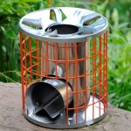
…. Or what about the rocket stove? A wood burning fire wastes most of its heat as well as producing smoke pollution. A rocket stove is an efficient cooking stove using small pieces of wood fuel which is burned in a simple high-temperature combustion chamber containing a vertical chimney and a secondary air supply, which ensures almost complete combustion prior to the flames reaching the cooking surface.
To read more about rocket stoves visit http://www.rocketworks.org/products/gasifying-rocket-stove/
Other simple ways to save electricity
- Turn off your oven ten minutes before the food is ready, the oven will retain its heat for that long.
- Use a kettle to boil water for cooking as it is quicker and uses less energy than a pot on the hob.
- Always match the size of the pan with the size of the stove plate.
- Use a microwave to cook as it is quicker and cheaper, 1 oven uses the same power as 18 microwaves.
- Only fill kettle with the amount of water that you need.
- Cut food into smaller sections before cooking to help it cook quicker.
- Make your toast in a toaster, not under the grill.
- Don’t keep opening the oven door while you are cooking.
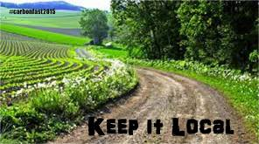 |  |  |  |  |  | Wednesday 25 February  Buy local. Have a dinner with ingredients from only your area and taste the deliciousness from what can be made near you!
Ezekiel 47:12 ESV “And on the banks, on both sides of the river, there will grow all kinds of trees for food. Their leaves will not wither, nor their fruit fail” - Buy local, reduce your food miles!
Have a diner with ingredients from only your area and taste the deliciousness from what can be made near you!
What on earth are food miles?
They are the distance that your food travels from the grower to your plate, including travel to and from processor and retailer.
Why should I want to reduce them?
- Because transporting your food long distances involves lorries and aeroplanes. And lorries and aeroplanes use lots of fuel and emit tons of CO2 emissions, contributing to global warming.
- Buying locally prevents some countries from cutting down forests and losing their own food, because big companies see food as a commodity, rather as a way to feed the people of that country.
- Locally grown food tastes better. It is usually picked in the last day or two. Produce that has been trucked or flown in is much older. fresh produce loses nutrients quickly
- Local food supports local people and creates jobs.
- Buying local food creates community!
How to reduce food miles:
- When shopping in supermarkets, check the labels. Buy food that is grown or produced locally.
- Eat what’s in season. It won’t have travelled as far as out-of-season fruit and vegetables.
- Visit your local Farmers’ Market.
- Find your local farm shops, producers and pick-your-own farms
- Grow your own - start a veggie patch in your back garden. Support your local greengrocer, butcher and fishmonger, and ask them to stock more local produce.
- Walk or take the bus to your local shops. This way you won’t add to the food miles already accrued.
As you enjoy your ‘local’ meal, make a list of potentially the number of people that you have contributed something to their well being through the products you bought.
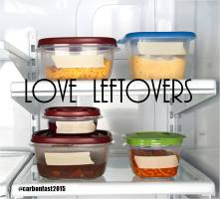 | Thursday 26 February  Write down what food you throw away this week. Aim to reduce it by a third by eating leftovers and shopping more carefully – using a list and planning your meals
WAR ON WASTE
When all of them had enough to eat, Jesus spoke to his disciples. “Gather the leftover pieces,” he said. “Don’t waste anything.” John 6:12
In the feeding of the 5000, Jesus told the disciples to collect up all the food and not to waste anything. I wonder who the people were who received those leftovers? - the elderly, the orphans, the physically challenged, who had not been able to walk to where Jesus was preaching.
How would Jesus feel about the amount of waste we create and throw away now?
At the Rio + 20 conference food waste was highlighted as a key problem. “Food wasted by consumers in high-income countries (222 million tons) is roughly equal to the entire food production of sub-Saharan Africa (230 million tons).”
Here is South Africa a staggering one third of annual food production is wasted! Some of it is on the farms, where products are considered “substandard quality” and are left to rot. Some of it is during transportation from farm to shop. More food is wasted in shops as it passes its sell by date.
And then there is me, and you. We buy too much, cook too much, and leave too much on our plates.
Our challenge today is to write down what food you throw away this week. Commit yourself to shopping more carefully, preserving leftovers, giving to those in need, and composting to improve your garden….
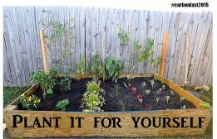 |  |  |  | Friday 27 February  Smart Fish Friday  Grow vegetables, herbs and fruit in your garden. If you don’t have one, start one or use pots on a windowsill or in a sunny spot
GROW SOMETHING
Then God said, “I give you every seed-bearing plant on the face of the whole earth and every tree that has fruit with seed in it. They will be yours for food. Gen 1:29
During World War 2 when there was a food crisis, the government initiative a campaign called “Dig for Victory” These gardens were also considered a civil “morale booster” in that gardeners could feel empowered by their contribution of labor and rewarded by the produce grown. This made victory gardens a part of daily life on the home front.
We have a food crisis in our World and perhaps now is the time that we encourage all Christians to take this small action to grow something in their homes. How satisfying to put your own chives into a salad or to share the excitement of your granddaughter as she sees a tiny tomato growing on the tomato that she planted herself.
By growing something, we also become co-creators with God and learn something of the joy of growth.
- Remember those bean sprouts you did in primary school? http://www.wikihow.com/Grow-Bean-Sprouts-Indoors - grow some of those to throw into crunchy salads.
- How about some herbs on your window sill and grow from there! http://www.bbcgoodfood.com/howto/guide/growing-your-own-herbs
- And if you want to start a veggie garden: http://home.howstuffworks.com/starting-a-vegetable-garden.htm
 |  |  |  |  |  |  |  | Saturday 28 February  Use a smaller plate, you will have leftovers to eat later, will reduce calories and will not provide as much demand on the production of food
SHRINK YOUR PLATE
“I have learned the secret of being content no matter what happens. I am content whether I am well fed or hungry. I am content whether I have more than enough or not enough”. Phil 4:12
The global increase in obesity rates over the past 30 years has been paralleled by an increase in the portion size of many foods. A friend of mine who runs a small business making kitchen cupboards says that the cupboards he takes out of older houses can often not be reused, because our modern plates don’t fit!
Items available at fast food restaurants are estimated to be 2 to 5 times larger than 2 decades ago!
Here are a few suggestions on how to shrink that portion size
- Use smaller plates! Use the smallest plates you have in your cupboard. Psychologically the helping will feel bigger!
- Fill up your plate with healthy stuff, like vegetables or salad.
- Fill the plates and then put the leftovers in the fridge. If you leave them on the table everyone will come for seconds, hungry or not!
- Enough is enough. Eating too much is bad for your body and bad for the planet…..
Moving (1 – 7 March)
 |  |  |  |  |  |  | Sunday 1 March  Psalms 20:7 -: Some trust in chariots and some in horses, but we trust in the name of the Lord our God  FAST FOR THE CLIMATE  And when they had fasted and prayed, and laid [their] hands on them, they sent [them] away. Acts 13:3
Fasting in the Bible is not associated with inaction. It is associated with drawing close to God in order to make a difference in the world. This week we consider our lifestyle in the area of ‘moving”. We live in a mobile society where our form of transport is often associated with status. As we consider a simpler lifestyle, we need to move towards smaller cars, lift sharing, public transport, scooters, bicycles and best of all our feet!!
Today is the first of March, we would like to encourage you to join the fast and pray for the climate movement.
When Typhoon Haiyan had just devastated the Philippines in November last year, climate commissioner Yeb Saño was at the UN climate talks in Warsaw. His own family was caught up in the disaster that killed thousands and destroyed homes and livelihoods across the country.
In a moving speech he said he would not eat until countries at the Warsaw conference delivered actions that would ‘stop the madness’ of the climate crisis.
Hundreds of others from around the world chose to fast with him in solidarity.
Despite this, the Warsaw meeting saw countries, like Japan, actually winding back their climate commitments, seemingly in denial that all countries will need to commit and contribute to the comprehensive, global climate action plan which is due in Paris in 2015.
The Fast For The Climate has grown into global movement with participation of youth groups, environmental groups and faith-based groups, who all want urgent action on climate change by governments this year.
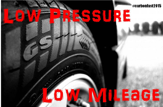 | Monday 2 March  Meat Free Monday  Check your tyre pressure, under inflation can cause a 5% decrease in petrol mileage, releasing more pollution.  Time to re-tyre!  You’ll travel safely; you’ll neither tire nor trip. Prov 3:23
We often don’t think of tyres as being an environmental issue. By maintaining them properly you help conserve the energy and resources that would go into making new ones, save petrol, and reduce the problems created when they are thrown away. Tyres are bulky, do not decompose and provide places for mosquitoes to breed.
Tyre trivia
- It takes half a barrel of crude oil to produce the rubber in one lorry tyre
- Worldwide every year 3 billion tyres, yes 3 billion! are discarded
What to do?
- Keep your tyres inflated. This preserves the life of the tyre and can improve your fuel consumption by 5%.
- Ask your tyre dealer if they recycle, if they don’t then say you will buy from the one that does!
- When you change your tyres, change to radial, they do improve mileage
- Recycle! Producing recycled tyres saves 70% of the energy it takes to make them new. They can be used for carpet padding, sporting goods, and added to playgrounds and running tracks.
- Re-use tyres for community projects. They can be used for crèches, for foundations for planting veggies!
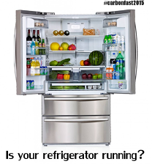 | Tuesday 3 March  FIX YOUR FREEZER  “By the breath of God ice is given, and the broad waters are frozen fast” Job 37:10
For most people the fridge is the item in the house which uses the second largest amount of electricity because it is on all the time. Here’s what to do:
Switch on ‘Energy saver” feature if you have one..
Many fridges have small heaters that keep moisture from forming on the cabinet. This can be turned off with the “Energy Saver”.
Set the temperature for only as cold as you need it.
Fridge should be 36-40F, and the freezer should be 0-5F (-17 to -10C). To test the fridge temperature, put a thermometer in a glass of water in the center of the fridge and leave it there for 24 hours. To test the freezer temperature, put the thermometer between two frozen packages. If the temperature is colder than needed, then set the fridge to a warmer temperature.
Don’t put hot foods in the fridge.
One to two hours of cooling off time will definitely make your refrigerator work less. You can greatly cool items by putting them in a container and soaking them in a pot of cold water for 15-30 minutes, which means they can go into the fridge faster if you are worried about them going off..
Thaw frozen foods in the fridge rather than on the counter.
They’ll help cool the fridge as they defrost.
Pick a good spot for the fridge.
Position your fridge out of direct sunlight, and away from the oven. If you cant then make sure there as at least 5cm of space all around to allow for circulation.
Door Openings.
Every time you open the door you are wasting electricity as the fridge tries to cool down the whole room!
Defrost your freezer regularly
More frost makes the freezer work harder.
Cleaning the coils helps a little.
The coils are the winding black pipe either on the back of the fridge, clean with a brush or vacuum.
Make sure the gasket/sealer is in good shape.
If parts of it are coming off, then cold air is escaping, re-attach it with adhesive.
Replace your fridge
Older fridges are incredibly inefficient pre 2001 fridges use 1400 kWh a year, while a modern energy-efficient model uses only 350 kWh — a whopping 75% reduction.
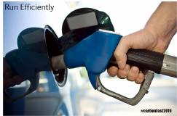 |  |  | Wednesday 4 March  Keep your car tuned up, track your petrol mileage. Your wallet will be fat and your emissions low.  Care for your car!  “Go to the village ahead of you. As soon as you get there, you will find a donkey’s colt tied up. No one has ever ridden it. Untie it and bring it here. ³¹ Someone may ask you, ‘Why are you untying it?’ If so, say, ‘The Lord needs it.’ ” Luke 11:30-31
When Jesus came into Jerusalem, he did not choose a top of the range Arab stallion. The Gospels make much of the fact that he chose to enter Jerusalem on a donkey, on the colt of a donkey. For Jesus transport was not associated with status.
We also need to move away from the values of society that says “you are what your drive” A car is a method of transport and we need to choose the most efficient. Getting good mileage out of your car is not just a matter of the environment – a fuel efficient vehicle is less destructive than a petrol guzzler. And it feels good on your pocket too!
Did you know - There are more than 1 BILLION cars on the road in the world.
The environmental impact of transport is significant because it is a major user of energy, and burns most of the world’s petroleum. This creates air pollution, including nitrous oxides and particulates, and is a significant contributor to global warming through emission of carbon dioxide for which transport is the fastest-growing emission sector. By subsector, road transport is the largest contributor to global warming.
What to do
- Keep your car tuned up. A well tuned car uses 9% less petrol.
- Keep track of your petrol mileage. If it suddenly changes you can quickly sort out the problem with your car.
- Do not idle your car unnecessarily. It takes less petrol to start a car that to let it idle for more than one minute. Switch off!
- Keep fuel filters clean
- Stay light. Don’t leave heavy things in your car. An extra 50 kg in your boot (110lb in your trunk J) will reduce fuel economy by 1%
- When it comes to buying a new car, research petrol economy before you decide which make to search for.
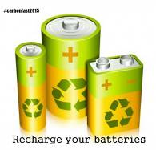 | Thursday 5 March  Recharge your batteries: Rechargeable batteries can last 500 times longer than single use, and always find a place to recycle them.  “Let us not become weary in doing good,” Galatians 6:9
Did you know?
Every year over 15 billion batteries are produced and sold worldwide Household batteries that are thrown out with the rubbish end up in landfills where they corrode and break apart, releasing dangerous lead and acid into the soil. Batteries that are incinerated reduce toxic chemicals into the air.. Many are alkaline batteries which are discarded after a single use. Fortunately, thanks to ongoing advances in both batteries and battery chargers, alkaline batteries can be replaced with higher capacity, environmentally friendly, rechargeable Lithium-ion batteries.
Recycle
Once a lead acid battery has died, there is no chance of a resurrection, however it can be effectively recycled. It will be sorted and placed into a battery breaker and pulverised into small coin shaped pieces. These pieces are placed into a tank and the dissimilar densities are separated––heavier pieces, such as lead sink, while lighter pieces, like rubber and plastic float. Liquids, such as water and acid go into a neutralising solution, and once the PH is neutral, it is innocuously discarded into the sewage system. The plastic is melted down, the lead is cleaned of impurities, smelted into ingots and both are remoulded into new batteries.
Lead-acid batteries are an environmental success story with more than 90% of all scrap batteries successfully recycled in South Africa. This is compared with 70% of beverage cans, 65% of newspapers, 30% of plastics, and 26% of glass.
WHAT TO DO
- Use rechargeable batteries. they last 500 times longer than alkaline batteries
- Use mains power instead of batteries whenever possible
- Find out where to recycle your batteries and organize a system to help others to recycle too.
 | Friday 6 March  Smart Fish Friday  Conserve your light, turn off fixtures when not in use, and use LED and other wattage lowering options  LESSEN YOUR LIGHTS  “Neither do people light a lamp and put it under a bowl. Instead they put it on its stand, and it gives light to everyone in the house”. Matt 5;15
How to save electricity on lighting
Lighting is probably the easiest area to save in. Switch to energy saving bulbs.
Save 70-90% right away by using LED or CFL lights. Here is why:
“Traditional incandescent bulbs are small heaters that give off a little bit of light—something you know if you’ve ever touched a bulb that’s been on for a while. These bulbs were technological wonders when they were patented in 1880, but today they are inefficient dinosaurs. They waste energy and money, and they are responsible for millions of tons of global warming pollution.”
LED is better but the bulbs are expensive. You will pay them off eventually but if the cost is too high, go with CFL. Make sure you get them bright enough -multiply by 6, a 10 watt LED is a 60 watt equivalent. But CFLs with a warranty, the cheap ones burn out fast.
Turn off lights when you’re not using them, even for just a few minutes.
The idea that lights (whether regular or fluorescents) use extra electricity to start up is a myth.
Use a motion sensor
Exterior security lights automatically shut off after 1-15 minutes, so you’re not paying to run them all night.
Use the lowest-wattage bulbs for lights that are always on (e.g., stairways).
Replacing 75-watt bulbs with 15-watt bulbs reduces energy usage by 80%. Replacing them with LED or CFL lights saves even more.
Install a skylight.
Using natural lighting saves a bunch of energy and produces a much nicer environment besides. Modern skylights are available which let in only the light and not the heat.
 | Saturday 7 March  Find a Friend  “And the Samaritan put him on his own beast, and brought him to an inn and took care of him.”… Luke 10:44
We have got into the habit of travelling alone, one person in a car. This makes no sense in terms of saving petrol, money and the planet..
Here are some ways to reduce your petrol costs and your carbon footprint
- Find a friend. For those regular trips can you car pool? If you don’t know anyone from your area who works in the same part of town, then try websites like Lift Shares
- Check out your public transport options. It might not work every time, but use it when it does.
- Combine your trip with another.
- What about your bike! Get in shape too
- Couple of km? – walk!
- Phone ahead – avoid that unnecessary journey by phoning ahead to see if the article you want is in stock
- Think it through – do you need to do this trip at all
- Telecommute – will they allow you to work from home from time to time?
- Skype your meetings! Is it really necessary to travel for that meeting or can you connect on skype?
- Buy on the internet.
- Use Uber rather than a sedan taxi company. This is a web based taxi company that connects you with the driver closest to you so they don’t travel great distances to come and get you. usually cheaper too

Climate Change Prayer

Holy God,
earth and air and water are your creation,
and every living thing belongs to you:
have mercy on us as climate change confronts us.
Give us the will and the courage
to simplify the way we live,
to reduce the energy we use,
to share the resources you provide,
and to bear the cost of change.
Forgive our past mistakes
and send us your Spirit, with wisdom in present controversies
and vision for the future to which you call us
in Jesus Christ our Lord. Amen.

