**JAEI ENVIRONMENTAL CORNER**

**Living Green - Why bother?**

With all the hype of modern technology and dreams of easy lifestyles, the question of *“Why bother living green”* is heard over and over again.

People who consciously live more green are often viewed as extremists and “*paranoid greenie*s”. The extremists may even shop in over-priced organic stores as a result of their environmental paranoia and live lives consumed by the fear of chemicals, processed foods, and the destruction of Earth. ….. On the other side of the scale are those who ignore the environmental crisis and live to accumulate as much of everything that they can – be it money and/or processions. But are the rest of us missing something? For some, a natural lifestyle requires too much planning and research. For others, it seems too expensive. Some also believe it’s just plain weird.

In his foreword to *“Caring for Creation: Ryan the Rhino” 1* Archbishop Thabo Makgoba states**:**

*Romans 8:22 “We know that the whole of creation has been groaning”. (Bible Reading: Romans 8:18-23)*

*Paul in his letter to the Romans speaks of the hurt which creation is suffering. Humans have sinned in the way we have destroyed parts of God’s creation. We think of pollution spewed into the air each year by our factories and motor cars, the industrial waste polluting our rivers and lakes, and the loss of thousands of species of fish, insects and other small animals. We use and abuse nature without realising its value, leaving behind toxic waste and mountains of indestructible garbage. We are also contributing to the changes in climate which will lead to further destruction as well as hunger and famine for humans. We do not hear the cry of nature, we do not stand in awe of it, we merely treat it as an object to be used for our benefit. My prayer is that this resource (“Caring for Creation”) will be used widely so that our children can learn again to reverence the gift of creation and that they would in turn inspire their parents.”*

So what are the benefits of a greener lifestyle?

The advantages to living a more sustainable lifestyle far outweigh any **fear** or **discomfort** of change you may have. Although we can be comfortable with the habits we’ve developed, that doesn’t mean they are the best thing for us or our world. A more eco-conscious lifestyle can bring a whole host of benefits to you personally:

* Cost-effectiveness
* Greater appreciation for what you already have (people, places, and things)
* **Increased confidence** due to newly acquired skills of self-reliance
* Possible weight loss and increased fitness (better eating & walking more)
* A **healthier, more stable planet** **for future generations**
* The joyous feeling of being a part of something worthwhile

Such benefits are achieved through the many different methods of living an eco-lifestyle. For most people, living without a car isn’t an option. While that is unfortunate, it is a reality of some communities, but it doesn’t mean there aren’t many other ways you can have a positive impact. Even the kind of car you choose to drive can reduce waste and pollution. Add in your food choices, hobbies, electronics, and holidays, and you’ve got **countless opportunities** for worthwhile sustainable change.

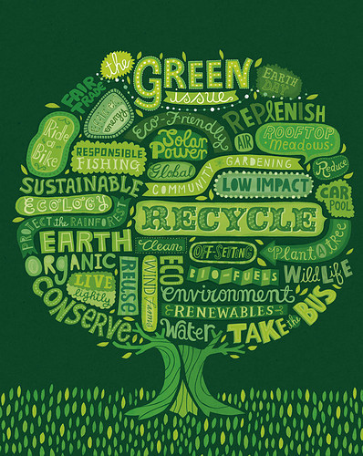No one is perfect, and no one’s lifestyle is likely to be 100 percent planet-friendly. Often, one conscious choice leads to another and another and another. Before you know it, your life is transformed with a **feeling of purpose**, thanks to a sense of community and the worthwhile accomplishment of being a part of something bigger than yourself.

Although it would be great if everyone rode a bicycle, grew their own food, and lived off solar power, that isn’t likely to happen for many decades. Until then, every change counts, every purchase (or lack thereof) counts, **every action counts** and, no, you don’t have to be an extremist to make positive changes to your lifestyle - living a sustainable lifestyle is the only thing worth counting.

So, let’s all do the best that we can to remain informed while living the healthiest life we can. It’s as simple as that!

***Try these hints:***

* **Change a light -** Replacing one standard light bulb with a compact fluorescent bulb will save 68 kg of carbon dioxide per year
* **Drive less -** Walk, cycle, carpool or take public transport more often. You’ll save a kg of CO2 for every 3 km you don’t drive
* **Recycle more -** You can save 1089kg of CO2 per year recycling just half your household waste (imagine what you can save if you recycle all your waste?! ….
* **Check your tyres -** Keeping your tyres inflated properly can improve fuel efficiency by over 3%. Every 4.6 litres of petrol saved keeps 9kg of CO2 out of the atmosphere
* **Use less hot water -** It takes a lot of energy to heat water. Use less hot water by installing a low-flow showerhead (159kg of CO2 saved annually) and washing your clothes in cold water (227kg saved per year)
* **Avoid products with a lot of packaging -** You can save 544kg of CO2 if you cut down your waste by 10%
* **Adjust your geyser thermostat -** Just by decreasing the temperature on your geyser thermostat can save about 907kg of CO2 annually
* **Plant a tree -** A single tree absorbs about a ton of CO2 in its lifetime
* **Turn off electronic devices -** Turning off your TV, DVD player, stereo and computer when not in use will save 100s of kilos of carbon dioxide a year
* 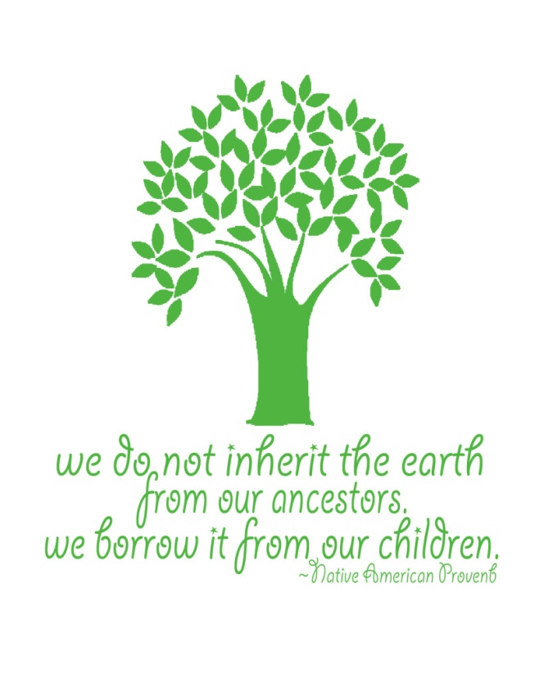**Spread the word -** Speak to your family, friends and colleagues and encourage them to cut down on CO2 emissions

**www.jaei.org.za**

**1** *Caring for Creation: Ryan the Rhino: The story of Creation*

A Sunday School Resource on Caring for Creation – available as download from <http://www.greenanglicans.org/wp-content/uploads/2013/08/Ryan-the-rhino-colour-final-Colour.pdf>