
JAEI ENVIRONMENTAL CORNER

How to Compost In 5 Simple Steps
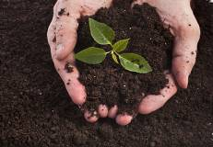
Winter is upon us and now is a good time to start preparing for Summer!
Want to know how to compost? It may sound intimidating, but it’s surprisingly easy if you break it down into 5 simple steps.
Step 1: Understand The Composting Basics
Review the composting infographic from PBS to understand the end-to-end composting process…
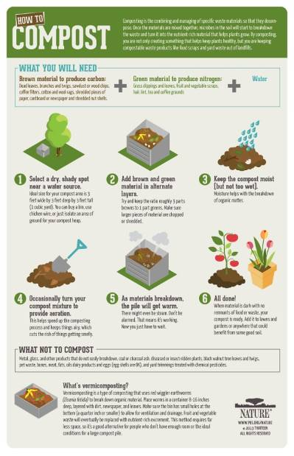
…and then, review the infographic from The Enduring Gardener which summarizes what to compost and what to throw away.

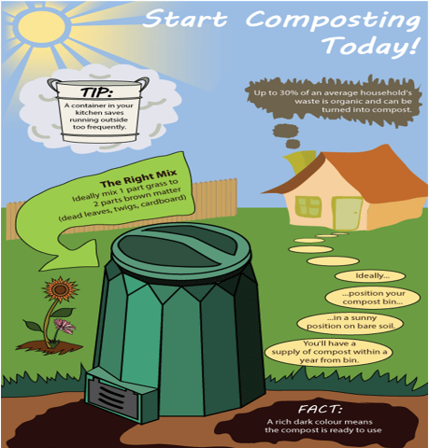

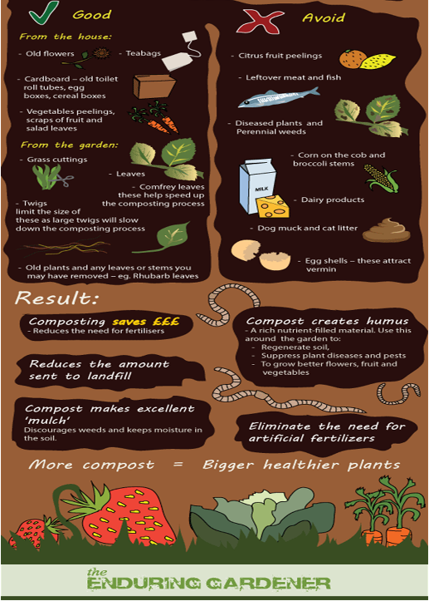

Step 2: Set Up Your Outside Compost Bin
Although any large container can be used, it is probably better to purchase a compost maker from a garden or hardware store.
Place the bin in an inconspicuous and far-but-not-too-far-away position so that any smells can be avoided, but where the compost process can be monitored and watered when needed.
Step 3: Set up for kitchen scrap collection
Set up an inside compost container with a lid in the kitchen to collect food scraps (see above graphic for what is able to be composted and what is not)
Step 4: Get Into A Routine
As with many other gardening efforts, composting takes some attention. Empty the indoor compost container into the outdoor compost bin once a week. This may be done more or less frequently s needed but needs to become routine.,
Check and water weekly. Again, the frequency with which this is done will vary based on the compost contents and status. If the mix is dry, add some water. If the mix is wet, don’t.
Step 5: Don’t Worry — Let Nature Do Its Work!
Be patient - this is not a speedy process so let Mother Nature get on with the job of decompose the scraps. You will be making a difference with your composting efforts — reducing food waste that would otherwise end up in the landfill and recycling those valuable resources to create healthy soil amendments - and hopefully you will use the outcomes to benefit your garden and grow food or flowers for your family.
With acknowledgements to http://www.simplygreen.co.za/

