JAEI Enviro-corner

 | Lenten Fast for the Environment - 2016
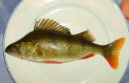 | Monday, 15 February  Meat Free Monday  Is it sustainable?  In his hand is the life of every living thing and the breath of every human being.” [Job 12:10]
All living beings are all precious to God – not just humans. “… even the hairs of your head are all counted.” And, likewise, not even a single sparrow “is forgotten in God’s sight.” [Luke 9:6-7] “Your righteousness is like the mighty mountains, your judgments are like the great deep; you save humans and animals alike, O Lord.” [Psalm 36:6]
Given God’s great love for all creatures, we need to reflect on our practice of eating meat farmed in factory farms.
Meat & chicken
- Ask questions as to how the meat supplied to supermarkets is raised. Can you switch to organic & free range?
Fish
- Is the fish that you buy from sustainable stocks? Consult the South African Sustainable Seafood Initiative (SASSI) list. SMS the name of the fish to 079 499 8795 or download you own list from www.wwfsassi.co.za
- Does packaged fish (tins or boxes) bear the Marine Stewardship Council (MSC) endorsement?
- Is the tinned tuna “dolphin friendly”?
Game
- Has the game been hunted ethically and within the prescribed hunting season?
Honey
- Does the honey come from a “badger friendly” source?
Boycott unsustainable products & know the best and worst products
NB! - Never buy ANYTHING that originates from any endangered or threatened species!
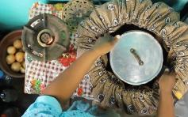 | Tuesday, 16 February  Wonderbags, Rocket stoves and other creative ideas  Exodus 12:8 “They shall eat the flesh that night, roasted on the fire; with unleavened bread and bitter herbs they shall eat it.”
There are lots of creative ways to save on electricity in our cooking processes. During the second world war when fuel was scarce, “hay boxes” were commonly used. These “boxes” have evolved over the years, but are still as economical and environmentally friendly as they ever were.
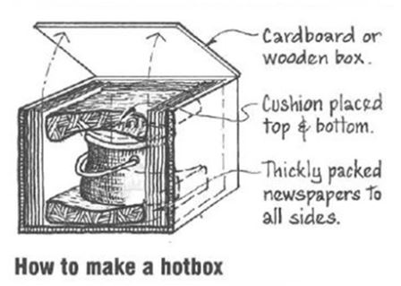
To make one, fill a cardboard box with hay, shredded paper or polystyrene bits. Put you food into a pot with a lid, bring to boiling point and simmer for ten minutes. Then put your pot into the filled cardboard box. Leave it overnight and voila! Your food is cooked.
There are many creative ideas available of ways to reduce your cooking fuel and costs.
One of these is the Wonderbag, an innovative insulated slow-cooking bag designed to save you time, effort and energy. The Wonderbag is a simple but revolutionary concept: simply bring your food to the boil on an ordinary stove, then switch off and tuck your hot cooking pot up in the cosy, electricity-free Wonderbag for a delicious slow-cooked meal, with all the nutrients locked in. Use the Wonderbag to cook stews, curries, soups and casseroles, while you spend less time in the kitchen and more relaxing with your loved ones No plugs, no fuss!
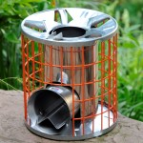
To read More about Wonderbags visit http://wonderbagworld.com/international
…. Or what about the rocket stove? A wood burning fire wastes most of its heat as well as producing smoke pollution. A rocket stove is an efficient cooking stove using small pieces of wood fuel which is burned in a simple high-temperature combustion chamber containing a vertical chimney and a secondary air supply, which ensures almost complete combustion prior to the flames reaching the cooking surface.
To read more about rocket stoves visit
http://www.rocketworks.org/products/gasifying-rocket-stove/
Other simple ways to save electricity during cooking
- Turn off your oven ten minutes before the food is ready, the oven will retain its heat for that long.
- Use a kettle to boil water for cooking as it is quicker and uses less energy than a pot on the hob.
- Always match the size of the pan with the size of the stove plate.
- Use a microwave to cook as it is quicker and cheaper, 1 oven uses the same power as 18 microwaves.
- Only fill kettle with the amount of water that you need.
- Cut food into smaller pieces before cooking to help it cook quicker.
- Make your toast in a toaster, not under the grill.
- Don’t keep opening the oven door while you are cooking.
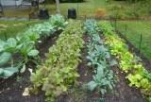 | Wednesday, 17 February  Buy local - reduce your food miles  “And on the banks, on both sides of the river, there will grow all kinds of trees for food. Their leaves will not wither, nor their fruit fail” - Ezekiel 47:12 ESV
Have a diner with ingredients from only your area and taste the deliciousness from what can be made near you!
What on earth are food miles?
They are the distance that your food travels from the grower to your plate, including travel to and from processor and retailer.
Why should I want to reduce them?
- Because transporting your food long distances involves trucks and planes. And trucks and planes use lots of fuel and emit tons of CO₂ emissions, contributing to global warming.
- Buying locally prevents some countries from cutting down forests and losing their own food, because big companies see food as a commodity, rather as a way to feed the people of that country.
- Locally grown food tastes better. It is usually picked in the last day or two. Produce that has been trucked or flown in is much older. fresh produce loses nutrients quickly
- Local food supports local people and creates jobs.
- Buying local food creates community!
How to reduce food miles:
- When shopping in supermarkets, check the labels. Buy food that is grown or produced locally.
- Eat what’s in season. It won’t have travelled as far as out-of-season fruit and vegetables.
- Visit your local Farmers’ Market.
- Find your local farm shops, producers and pick-your-own farms
- Grow your own - start a veggie patch in your back garden. Support your local greengrocer, butcher and fishmonger, and ask them to stock more local produce.
- Walk or take the bus to your local shops. This way you won’t add to the food miles already accrued.
As you enjoy your ‘local’ meal, make a list of potentially the number of people that you have contributed something to their wellbeing through the products you bought.
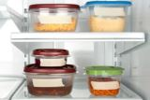 | Thursday, 18 February  War on waste  “When all of them had enough to eat, Jesus spoke to his disciples. “Gather the leftover pieces,” he said. “Don’t waste anything.” John 6:12
In the feeding of the 5000, Jesus told the disciples to collect up all the food and not to waste anything. I wonder who the people were who received those leftovers? - the elderly, the orphans, the physically challenged, who had not been able to walk to where Jesus was preaching.
How would Jesus feel about the amount of waste we create and throw away now?
At the Rio+20 conference food waste was highlighted as a key problem. “Food wasted by consumers in high-income countries (222 million tons) is roughly equal to the entire food production of sub-Saharan Africa (230 million tons).”
Here in South Africa a staggering one third of annual food production is wasted! Some of it is on the farms, where products are considered “substandard quality” and are left to rot. Some of it is during transportation from farm to shop. More food is wasted in shops as it passes its sell by date.
And then there is me, and you. We buy too much, cook too much, and leave too much on our plates.
Our challenge today is to write down what food you throw away this week. Aim to reduce it by a third by eating leftovers and commit yourself to shopping more carefully, preserving leftovers, giving to those in need, and composting to improve your garden….. Shopping with a list helps curtail those “impulse buys”.
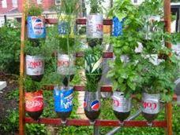 | Friday, 19 February  Smart Fish Friday  Grow something  Then God said, “I give you every seed-bearing plant on the face of the whole earth and every tree that has fruit with seed in it. They will be yours for food. Gen 1:29
During World War 2 when there was a food crisis, the government initiative a campaign called “Dig for Victory” These gardens were also considered a civil “morale booster” in that gardeners could feel empowered by their contribution of labor and rewarded by the produce grown. This made victory gardens a part of daily life on the home front.
We have a food crisis in our World and perhaps now is the time that we encourage all Christians to take this small action to grow something in their homes. How satisfying to put your own chives into a salad or to share the excitement of your granddaughter as she sees a tiny tomato growing on the tomato that she planted herself.
By growing something, we also become co-creators with God and learn something of the joy of growth.
- Remember those bean sprouts you did in primary school? http://www.wikihow.com/Grow-Bean-Sprouts-Indoors - grow some of those to throw into crunchy salads.
- How about some herbs on your window sill and grow from there!
ttp://www.bbcgoodfood.com/howto/guide/growing-your-own-herbs
- And if you want to start a veggie garden: http://home.howstuffworks.com/starting-a-vegetable-garden.htm
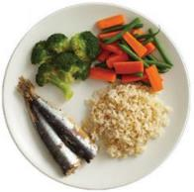 | Saturday, 20 February  Shrink your plate  “I have learned the secret of being content no matter what happens. I am content whether I am well fed or hungry. I am content whether I have more than enough or not enough”. Phil 4:12
Use a smaller plate!
The global increase in obesity rates over the past 30 years has been paralleled by an increase in the portion size of many foods. Items available at fast food restaurants are estimated to be 2 to 5 times larger than 2 decades ago!
Here are a few suggestions on how to shrink that portion size
- Use smaller plates! Use the smallest plates you have in your cupboard. Psychologically the helping will feel bigger, it will reduce calories and you will have leftovers to eat later! It will also not provide as much demand on the production of food.
- Fill up your plate with healthy stuff, like vegetables or salad.
- Fill the plates and then put the leftovers in the fridge. If you leave them on the table everyone will come for seconds, hungry or not!
- Enough is enough. Eating too much is bad for your body and bad for the planet…..
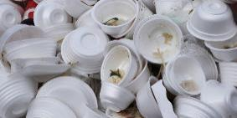 | Sunday, 21 February  Stamp out Styrofoam  Their land will be an object of horror and of lasting scorn; all who pass by will be appalled and will shake their heads. (Jerem 18:16)
Avoid using Styrofoam packaging, when buying a take-away use recycled paper or a reusable container.
Styrofoam is the common name for a type of expanded plastic called Polystyrene foam and is made from styrene, a derivative of the chemical benzene, which is fused into long chains and then expanded using heat and steam.
There are health risks associated with continual exposure to high quantities of Styrofoam, but the main negative aspect to Styrofoam is the negative effect it has on the environment. Styrofoam accounts for a huge proportion of garbage ending up in landfill sites and they are non-biodegradable, which means that once discarded they will remain in overcrowded landfills indefinitely.
Styrofoam is recyclable into new packing materials or other plastic products such as coat hangers and cd jewel cases. However, Styrofoam is not accepted at many recycling centers and the environmental cost of the recycling and re-manufacture processes is high.
The easiest way to reduce polystyrene foam waste is to replace disposable products such as cups, coolers, and lunch tray with reusable items. If disposable products are needed, there are numerous paper alternatives that are recyclable and/or biodegradable

We continue to pray for our Planet:
All-powerful God, you are present in the whole universe and in the smallest of your creatures.
You embrace with your tenderness all that exists.
Pour out upon us the power of your love, that we may protect life and beauty.
Fill us with peace, that we may live as brothers and sisters, harming no one.
O God of the poor,
help us to rescue the abandoned and forgotten of this earth, so precious in your eyes.
Bring healing to our lives, that we may protect the world and not prey on it,
that we may sow beauty, not pollution and destruction.
Touch the hearts of those who look only for gain at the expense of the poor and the earth.
Teach us to discover the worth of each thing, to be filled with awe and contemplation,
to recognize that we are profoundly united with every creature as we journey towards your infinite light.
We thank you for being with us each day
Encourage us, we pray, in our struggle for justice, love and peace. Amen
- Pope Francis

