JAEI ENVIRONMENTAL CORNER
Mind that Christmas Plastic!

Christmas is around the corner – a time of celebration and remembering the birth of our Saviour, Jesus Christ. … but it also comes with a time of parities, presents and fancy food.

It is unfortunate that Christmas has become so commercialised and many are drawn into the net of over-spending, over eating and becoming “partied-out”! As we go into a time of Advent in preparation to celebrate Christ’s birth with special anticipation, let’s also consider HOW we are going to celebrate this special day.

No doubt there will be the last-minute dash-around to buy a gift for Great-aunt Matilda (who you didn’t really think was going to make it to Christmas this year) and your neighbours new grandchild ……. or perhaps even your spouse! This will inevitably involve a lot of plastic. Buying ingredients for your Christmas dinner and everything that goes with that …. will inevitably involve a lot of plastic. We “need” decorations … that will inevitably involve a lot of plastic.

Now plastic is not necessarily a bad thing, but when there’s too much of it … it is! - a REALLY bad thing! Plastic is made from oil … oil is a fossil fuel … using too much fossil fuels adds to Climate Change … Climate Change adds to our weather problems … you get the picture!

Plastic, if not recycled, can take up to 500 years (sometimes more) to degrade and in the mean-time will cause havoc in our environment. Much of it will land up in landfills, and some will break down into smaller (tiny-tiny!) pieces and wash into water courses, into streams, rivers and eventually out to sea.

Many of us will be preparing for our yearly sojourn at the coast – lots of sea, sand, and sun. However, take a really close look at that beautiful beach – much of it will be covered with plastic pollution as is that seemingly never-ending ocean.

If you’re not spending your time on the beach, don’t think that you don’t have an impact on that mighty ocean – think again! – what we do here in Gauteng matters as much as those people at the coast!
Due to habitat destruction, overfishing and pollution, the ocean is losing the ability to provide the benefits that humans have come to rely on: food, livelihoods, climate regulation. All of this is happening in the face of a rapidly changing climate and acidification of seawater, which is reducing the ability of the ocean to absorb carbon and to regulate global temperatures and local weather patterns. This isn’t sustainable.
- Three out of every seven people in the world depend on seafood as their main source of protein.
- About 44 percent of the world’s population lives within 150 kilometres (93 miles) of the ocean.
- Some US$ 2.5 trillion per year of economic value is produced by the ocean.
Over 150 million tons of plastic are estimated to be present in the sea at present. Even deep sea crabs have been found with plastic inside them. If current trends continue the weight of the plastic will by 2050 be 700 million tons and outstrip the total weight of fish in the sea.
According to the Sustainable Seas Trust, the exact amount of debris entering the sea from South Africa or any other African country is not known. What is known, however, is that the rapid development of Africa, coupled with poverty, has seen waste accumulation outpace management.

Bottom line! …. Reduce your plastic use, and recycle all you can!!!
- Here are some pointers taken directly from the Two Oceans Aquarium website that give you food for thought and please take these points to heart and make them a part of your daily life!
http://www.aquarium.co.za/content/page/environmental-campaigns-landing
“As part of the Two Oceans Aquarium’s mandate to raise awareness about the environment and encourage a sustainable lifestyle, we champion a number of causes. These are just some of the issues that we find important. Join us by taking these simple steps in your journey to a greener footprint and a healthier, happier world.”

Rethink The Bag
Most plastic shopping bags end up in landfill or in the sea where they are often swallowed by animals. These animals suffer a terrible and slow death, after which the plastic bag still remains in the environment. Choose a beautiful reusable fabric shopper and say “no thanks!” next time the cashier asks if you would like to buy a plastic bag.
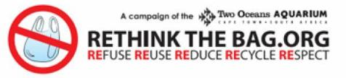

Straws Suck!
Straws are one of the most common rubbish items found on our beaches. Much like plastic bags, straws are often swallowed by marine creatures, resulting in blockages which ultimately cause death. Refuse this luxury item next time you buy a cold drink or milkshake, you’ll be surprised by how unnecessary it is.

Bust Your Need For Balloons
Balloons are festive and pretty, but this comes at a cost. Released balloons end up in the environment where they kill animals when they are mistaken for food and eaten. Animals are also strangled in balloon debris and die slow and unnecessary deaths. Biodegradable balloons take months, even years to degrade by which time the damage has already been done.

Tap In
South African tap water is safe to drink and amongst the best in the world! Often, bottled water is no different from tap water. Bottled water is sold at a premium due to the apparent convenience, but the result is just more unnecessary plastic waste that ends up in the environment. Keep a reusable bottle handy and fill it from a tap or water cooler.
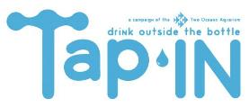

Bin Your Butts
Cigarette butts are the most commonly found litter item in the world! These butts (filters) are made from plastic fibres and do not biodegrade. Not only do they not break down, they are full of harmful toxins like nicotine and tar. These toxins leach into the soil and groundwater and can kill animals if eaten and fish if the butts end up in water. Please dispose of cigarette butts responsibly.
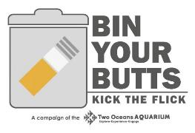

Cut A Loop
Box bands, and other loops formed by rubbish, can end up entangling land and sea animals to the point where they are slowly strangled to death. Make sure all looped refuse is cut before disposal (and recycled where possible) otherwise you are essentially throwing a noose into the environment!
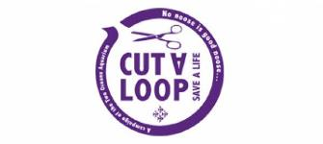

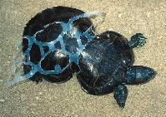

Peanut: The Story Behind a Poor Turtle Deformed by a Six-Pack Ring
Peanut, the small waisted turtle that obviously didn’t get her slender figure from exercising. Photos of this poor turtle have made the rounds across the internet, but what’s the story behind her travail? Apparently, she was trapped in a six-pack ring at a young age, couldn’t get out of it, and her body continued to grow around it.
A turtle’s shell protects its body and Peanut was able to live with the plastic around her waist for a while, but due to the deformation, some of her organs failed to develop completely. She was luckily found back in 1993 in Missouri and taken to a zoo in St. Louis were vets freed her from the plastic six-pack ring. She is still being looked after by the Missouri Department of Conservation and the good news is that she is ring-free and roaming around.
While Peanut’s story ended well (relatively speaking), she just highlights the effect our excess consumption and waste have wreaked on defenceless animals around the world.

http://inhabitat.com/peanut-the-story-behind-the-poor-sea-turtle-deformed-by-a-six-pack-ring/

Choose Sustainable Seafood
Many of our fisheries are in deep trouble – there are simply not enough fish left in the oceans to keep everyone in business. You can make a huge difference to our oceans’ resources by choosing to eat seafoods that are still plentiful and can cope with today’s fishing pressures.
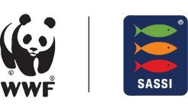

Choose the fish with the tick
You can contribute to the future of our marine world by choosing seafood products that are certified by the Marine Stewardship Council (MSC).
You can enjoy your seafood knowing that it can be traced back through the supply chain to the sustainable fishery that caught it. In this way, you make the best environmental choice in seafood.
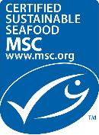

A Prayer to Keep Christmas Simple
Dear Lord, don't let us miss You this Christmas season. Help us to simplify our activities and traditions so we can focus our celebration on Your birth. Thank You for being the Prince of Peace, and I ask You for that supernatural peace to reign in our hearts. Thank You for the simple but life-changing message of Your love for us. In Jesus' Name,
Amen.

