JAEI Enviro-corner

Winds and Deserts!

15th June is Global Wind Day

17 June is World Day to Combat Desertification

Wind!
When we think of wind - John 3:8 comes to mind - “The wind blows wherever it pleases”.
We hear its sound, but cannot tell where it comes from or where it is going.
So let’s consider a few of the properties of wind.
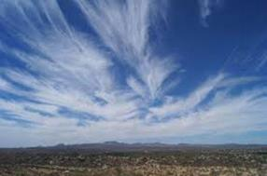
- Wind is moving air, and this fresh air is needed continually for life itself. Even seeds often require wind for their dispersal and subsequent growth. Similarly, the Holy Spirit is the presence of God, the source for all life.
- Wind has no material shape or form. It is invisible; we cannot see the source or the destination of wind. It is a mysterious, unseen force. Nevertheless, its presence is known by its effects.
Likewise, the unseen Holy Spirit can be experienced in a refreshing way. His presence is displayed in the work he does in human lives by transforming, sanctifying, encouraging, and teaching.
- Wind is a powerful force. It cannot be stopped or controlled by people. Likewise, the Holy Spirit is not subject to human control. The moving of the Holy Spirit is God at work.
- There is great variety in the wind. It may be a soft whisper gently rustling the leaves on the trees, or it may be a hurricane uprooting trees.
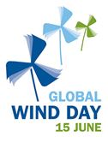
Likewise, the Holy Spirit may gently bring a person to Christ, such as a little child raised in a Christian home, or he may work in some climactic, dramatic way to bring conviction and conversion to the hardened sinner.
So wind, all round is pretty important and very useful.
Global Wind Day is a worldwide event that occurs annually on 15 June. It is a day for discovering wind, its power and the possibilities it holds to change our world. It is also a day for discovery and recognition of the work that has already begun by pioneers around the world. In more than 80 countries around the world, wind farms are in operation, generating energy from a clean and renewable source.
Thousands of individuals are involved in the production of energy from the wind, but for many people, wind energy is a mystery.
The inaugural year of Wind Day (it did not become Global Wind Day until 2009) was organised by EWEA (European Wind Energy Association – now WindEurope). The main idea was to coordinate events organised by national wind energy associations and companies active in the wind energy field. Wind Day in 2007 reached 18 countries in Europe, with a participation of around 35,000 people. In 2010, in collaboration with the Global Wind Energy Association, the idea of a global recognition was launched – South Africa became a firm participant in this initiative.

As a participant, South Africa can be proud to celebrate Global Wind Day in showcasing the results of renewable energy harvested by wind power that have been achieved to date.

Here is some information about wind power in South Africa:
- South Africa has gone from having just 8 wind turbines in 2012 to more than 295 to date;
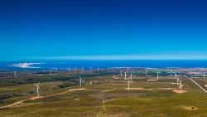
Wind farm in Jefferies Bay
- Renewable energy has empowered communities. More than ZAR 7 Billion has already been allocated to community uplift and socio-economic development from wind farms being developed under the Government’s Renewable Energy Independent Power Producers Procurement Programme (REIPPPP). This figure will increase significantly over the next three to four years as thousands more megawatts of wind energy are built.
- Wind farms creates jobs. 19, 414 person years of jobs were created by wind farms given the go ahead in REIPPPP Rounds 1 -3. 93.5% of those jobs were/are being carried out by South Africans and locally trained technicians.
- Energy from wind will avoid load shedding. Wind energy guaranteed that 117 hours of load shedding were avoided in 2014 - this equals 9 Gigawatt hours and an equivalent value of ZAR 800 million. Wind energy also saved ZAR 1.7 billion in coal and diesel fuel in 2014.
- Wind energy is economical. Newest prices for wind power under the REIPPPP are 40% cheaper per electricity unit than the newest coal (based on latest estimates for Medupi Coal Power Station, currently under construction).
- Private enterprise has invested ZAR 55 billion of funding in the wind industry over the last 3 years. South Africa only pays for the power produced.
Renewable energy from wind power will play a significant part in lessinging our present dependancy on fossil fuel (coal and gas) so is very good news to all South Africans.
Perhaps the very last verse in the very last Psalm says it all! …. "Let everything that has breath praise the Lord. Praise the Lord!"
Let your breath praise the Lord today and thank and praise the Lord for WIND!!

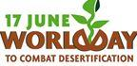
2016 World Day to Combat Desertification

The World Day to Combat Desertification has been observed since 1995 to promote public awareness relating to international cooperation to combat desertification and the effects of drought
Ever since, country Parties to the Convention, organizations of the United Nations System, international and non-governmental organizations and other interested stakeholders have celebrated this particular day with a series of outreach activities worldwide.
The World Day to Combat Desertification is a unique occasion to remind everybody that desertification can be effectively tackled, that solutions are possible, and that key tools to this aim lay in strengthened community participation and co-operation at all levels.

2016 Theme - Protect Earth. Restore Land. Engage People
There is probably no greater issue than land in the post-2015 Sustainable Development Goals that touches everyone. From the food we eat, to the clothes we wear and the houses we live – it all stems from land resources. In order to “leave no one behind” as proclaimed in the new Sustainable Development Goals, achieving land degradation neutrality needs to be in the forefront to meet our requirements and develop sustainability.
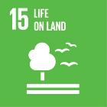

Sustainable Development Goal 15: Sustainably manage forests, combat desertification, halt and reverse land degradation, halt biodiversity loss
This year’s World Day to Combat Desertification advocates for the importance of inclusive cooperation to restore and rehabilitate degraded land and contribute towards achieving the overall Sustainable Development Goals. Land has been an overlooked component in sustainable development for years. Now, we view land as a vital link to provide solutions to cope with many other development challenges such as climate change, secure water and energy resources, promoting inclusive growth, and so on.
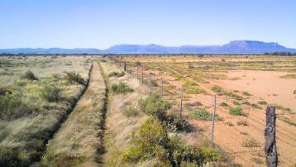
Forests cover 30 per cent of the Earth’s surface and in addition to providing food security and shelter, forests are key to combating climate change, protecting biodiversity and the homes of the indigenous population. Thirteen million hectares of forests are being lost every year while the persistent degradation of drylands has led to the desertification of 3.6 billion hectares.
Deforestation and desertification – caused by human activities and climate change – pose major challenges to sustainable development and have affected the lives and livelihoods of millions of people in the fight against poverty. Efforts are being made to manage forests and combat desertification.

Facts & Figures on Desertification:
- 2.6 billion people depend directly on agriculture, but 52 per cent of the land used for agriculture is moderately or severely affected by soil degradation
- As of 2008, land degradation affected 1.5 billion people globally
- Arable land loss is estimated at 30 to 35 times the historical rate
- Due to drought and desertification each year 12 million hectares are lost (23 hectares per minute), where 20 million tons of grain could have been grown
- 74 per cent of the poor are directly affected by land degradation globally

[Part of] Sustainable Development Goal 15 Target:
- By 2030, combat desertification, restore degraded land and soil, including land affected by desertification, drought and floods, and strive to achieve a land degradation-neutral world
- By 2030, ensure the conservation of mountain ecosystems, including their biodiversity, in order to enhance their capacity to provide benefits that are essential for sustainable development.

