JAEI ENVIRONMENTAL CORNER
Are YOU harbouring an alien?
Second week of October is National “Weedbuster” Week

….. Where do you come from? I’m NOT pleased to meet you! ….
A “weed” is defined as a plant that is growing in the wrong place, it’s really the same with invader species, except you REALLY DON’T want them in your garden!!! So, what’s the problem?
Invader species are species that have landed up on our doorstep from some other country/region, but instead of just “looking pretty”, they have made themselves most unwelcome. Because these invader species do not arrive here accompanied by all their natural enemies, they quickly out-compete and take over from our natural flora and negatively impact our biodiversity … and they are normally a very thirsty bunch as well! These negative impacts call for concerted action for the control of these invasive alien plants.
Invasive species (yes, there aren’t only plants that are invading our pad! ….) are controlled by the National Environmental Management Biodiversity Act (NEMBA) (Act 10 of 2004) – Alien and Invasive Species (AIS) regulations, which was gazetted on 1 August 2014 and became law on 1 October 2014.
To download a copy of the Act, visit https://www.environment.gov.za/sites/default/files/legislations/nemba10of2004_alienandinvasive_speciesregulations.pdf
In South Africa, the regulation lists a total of 559 alien species as invasive and further 560 species are listed as prohibited and may not be introduced into South Africa. We need to all join hands and together make a determined effort to control these invaders. We all can make a big difference as the sources of infestations are often in our gardens.
Here is a brief explanation of the four categories of Invasive Alien Plants (IAPs) as per NEMBA.
Category 1a:
Invasive species requiring compulsory control. Remove and destroy. Any specimens of Category 1a listed species need, by law, to be eradicated from the environment. No permits will be issued. - e.g. Iris pseudacorus (Yellow Flag Iris); Hydrocleys nymphoides (Water poppy)
Category 1b:
Invasive species requiring compulsory control as part of an invasive species control programme. Remove and destroy. These plants are deemed to have such a high invasive potential that infestations can qualify to be placed under a government sponsored invasive species management programme. No permits will be issued. - e.g. Solanum mauritianum (Bugweed)
Category 2:
Invasive species regulated by area. A demarcation permit is required to import, possess, grow, breed, move, sell, buy or accept as a gift any plants listed as Category 2 plants. No permits will be issued for Category 2 plants to exist in riparian zones. - e.g. Hypericum perforatum (St. John’s wort)
Category 3:
Invasive species regulated by activity. An individual plant permit is required to undertake any of the following restricted activities (import, possess, grow, breed, move, sell, buy or accept as a gift) involving a Category 3 species. No permits will be issued for Category 3 plants to exist in riparian zones - e.g. Jacaranda; Grevillea robusta (Australian silky oak.)
To view the full list of invader species as Gazetted on 29 July 2016 – visit:
https://drive.google.com/file/d/0B1rjSqrpPXSxZ3MyNHZpOGVDMXc/view
South Africa celebrates National “Weedbuster” Week the second week of October in order to raise awareness of the negative impact of invasive species. Invasive species are causing billions of Rands worth of damage to South Africa's economy each year. Invasive alien plants (IAPs) pose a direct threat not only to biodiversity, but also to water security, the ecological functioning of natural systems and the productive use of land.
Let’s have a look at a few of these interlopers that are causing havoc!

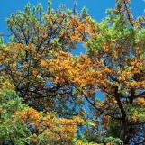 | AUSTRALIAN SILKY OAK  Scientific Name: Grevillea robusta  Alternative Common name: Silver oak; he-oka (English); Australiese silwereik  Origin: Australia  NEMBA Category: 3  Read more:http://www.invasives.org.za/component/k2/item/242-australian-silky-oak-grevillea-robusta
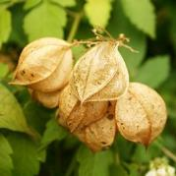 | BALLOON VINE  Scientific Name: Cardiospermum grandiflorum  Alternative Common name: Heart pea; heart seed (English); blaasklimop; opblaasboontjie (Afrikaans); intandela, uzipho (isiZulu)  Origin: Tropical South America (Brazil and eastern Argentina)  NEMBA Category: 1b  Read more: http://www.invasives.org.za/component/k2/item/213-balloon-vine-cardiospermum-grandiflorum
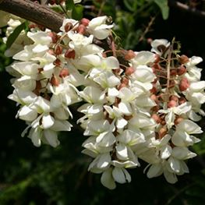 | BLACK LOCUST  Scientific Name: Robinia pseudoacacia  Alternative Common name: False acacia, locust tree, yellow locust (English); witakasia, valsakasia (Afrikaans)  Origin: North America  NEMBA Category: 1b  Read more: http://www.invasives.org.za/component/k2/item/333-black-locust-robinia-pseudoacacia
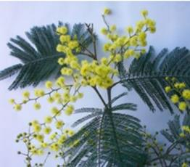 | BLACK WATTLE  Scientific Name: Acacia mearnsii  Alternative Common name: Black wattle, Swartwattel  Origin: Southeast Australia and Tasmania  NEMBA Category: 2  Read more: http://www.invasives.org.za/component/k2/item/205-black-wattle-acacia-mearnsii
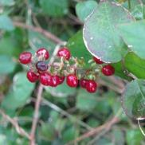 | BLOODBERRY  Scientific Name: Rivina humilis  Alternative Common name: Rivina, baby pepper, coral berry (English); bloedbessie (Afrikaans)  NEMBA Category: 1b  Read more: http://www.invasives.org.za/component/k2/item/327-bloodberryrivina-humilis
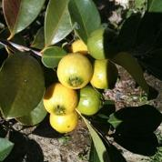 | BRAZILIAN GUAVA  Scientific Name: Psidium guineense  Alternative Common name: Brasiliaanse koejawel (Afrikaans) Koejawel, Brasiliaanse (Afrikaans) Guava, Brazilian (English)  Origin: Brazil  NEMBA Category: 1b  Read more: http://www.invasives.org.za/component/k2/item/323-brazilian-guava-psidium-guineense
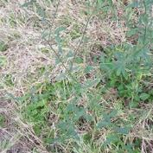 | BRAZILIAN VERBINA  Scientific Name: Verbena brasiliensis  Alternative Common name: Brazilian vervain (English), Gin case (English)  Origin: South America  NEMBA Category: 1b  Read more: http://www.invasives.org.za/component/k2/item/897-brazilian-verbina-verbena-brasiliensis
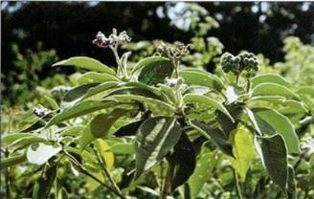 | BUGWEED  Scientific Name: Solanum mauritianum  Common name: Luisboom, Bugweed  Origin: South America (Argentina, Brazil, Paraguay and Uruguay)  NEMBA Category 1b  Read more: http://www.invasives.org.za/component/k2/item/351-bugweed-solanum-mauritianum
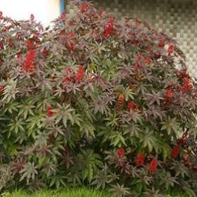 | CASTOR-OIL PLANT  Scientific Name: Ricinus communis  Alternative Common name: Castorbean, wonder tree (English); kasterolieboom, bloubottelboom, bosluisboom (Afrikaans); mohlafotha (Sesotho); mokhura (Pedi); mufuta (Shona); umfude (Ndebele); umhlakuva (isiZulu); umhlakuva (isiXhosa)  Origin: Tropical Africa  NEMBA Category: 2  Read more: http://www.invasives.org.za/component/k2/item/326-castor-oil-plant-ricinus-communis
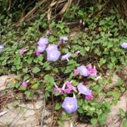 | COMMON MORNING GLORY  Scientific Name: Ipomoea purpurea  Alternative Common name: Gewone purperwinde (Afrikaans); ibhoqo; ijalamu; ubatata wentaba (isiZulu); imotyikatsana (isiXhosa).  Origin: Tropical America  NEMBA Category: 1b  Read more: http://www.invasives.org.za/component/k2/item/264-common-morning-glory-ipomoea-
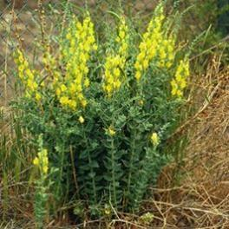 | DALMATIAN TOADFLAX  Scientific Name: Linaria dalmatica  Alternative Common name: Broadleaf toadflax, wild snapdragon  Origin: Western Asia and South-eastern Europe  NEMBA Category: 1b  Read more: http://www.invasives.org.za/component/k2/item/825-dalmatian-toadflax-linaria-dalmatica
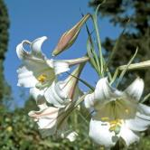 | FORMOSA LILY  Scientific Name: Lilium formosanum  Alternative Common name: St Joseph’s lily; trumpet lily (English); Sintjosefslelie; trompetlelie (Afrikaans)  Origin: Asia (Taiwan).  NEMBA Category: 1b  Read more: http://www.invasives.org.za/component/k2/item/276-formosa-lily-lilium-formosanum
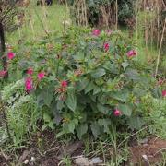 | FOUR O`CLOCK  Scientific Name: Mirabilis jalapa  Alternative Common name: Heart-leaf four-o'clock, heart-leaf umbrella-wort, snotweed, umbrella-wort. (English), Vieruurtjie (Afrikaans).  Origin: Tropical America  NEMBA Category: 1b  Read more: http://www.invasives.org.za/component/k2/item/677-four-o-clock-mirabilis-jalapa
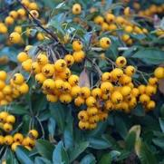 | HIMALAYAN FIRETHORN  Scientific Name: Pyracantha crenulata  Alternative Common name: Asian firethorn, variegated hawthorn.  Origin: Western China.  NEMBA Category: 1b  Read more: http://www.invasives.org.za/component/k2/item/759-himalayan-firethorn-pyracantha-crenulata
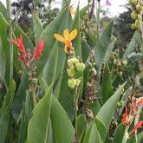 | INDIAN SHOT  Scientific Name: Canna indica  Alternative Common name: Garden canna; wild canna (English); tuinkanna; Indiese kanna (Afrikaans); udumbedumbe (isiZulu)  Origin: Caribbean region and tropical America  NEMBA Category: 1b  Read more: http://www.invasives.org.za/component/k2/item/211-indian-shot-canna-indica
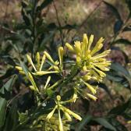 | INKBERRY  Scientific Name: Cestrum laevigatum  Alternative Common name: Cestrum  Origin: Brazil, South America  NEMBA Category: 1b  Read more: http://www.invasives.org.za/component/k2/item/457-inkberry-cestrum-laevigatum
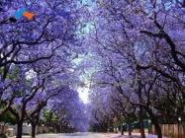 | JACARANDA  Scientific Name: Jacaranda mimosifoli  Alternative Common name: Blue Brazilian; blue jacaranda; Brazilian rosewood; fern tree (English); jakaranda (Afrikaans)  Origin: South America (north-west Argentina)  NEMBA Category: 3  Read more: http://www.invasives.org.za/component/k2/item/265-jacarandajacaranda-mimosifolia
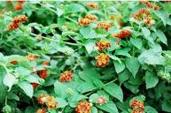 | LANTANA  Scientific Name: Lantana camara  Alternative Common name: Lantana  Origin: Central and South America  NEMBA Category: 1b  Read more: http://www.invasives.org.za/component/k2/item/267-lantana-lantana-camara
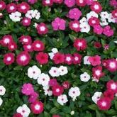 | MADAGASCAR PERIWINKLE  Scientific Name: Catharanthus roseus  Alternative Common name: Begraafplaasblom (Afrikaans)  Origin: Madagascar  NEMBA Category: 1b  Read more: http://www.invasives.org.za/component/k2/item/594-madagascar-periwinkle-cantharanthus-roseus
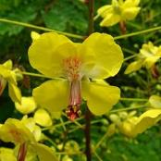 | MAURITIUS THORN  Scientific Name: Caesalpinia decapetala  Alternative Common name: Mysore thorn; shoofly; kraaldoring (Afrikaans); ufenisi; ubobo-encane (isiZulu)  Origin: Asia (India, Sri Lanka, China, Japan & Malaysia  NEMBA Category: 1b  Read more: http://www.invasives.org.za/component/k2/item/202-mauritius-thorn-caesalpinia-decapetala

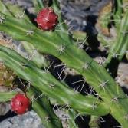 | MOON CACTUS  Scientific Name: Harrisia martinii  Alternative Common name: Torch cactus (English); toukaktus; kabelkaktus (Afrikaans)  Origin: South America (Argentina)  NEMBA Category: 1b  Read more: http://www.invasives.org.za/component/k2/item/257-moon-cactus-harrisia-martinii
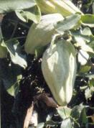 | MOTH CATCHER  Scientific Name: Araujia sericifera  Alternative Common name: Motvanger (Afrikaans)  Origin: South America  NEMBA Category: 1b  Read more: http://www.invasives.org.za/component/k2/item/227-moth-catcher-araujia-serifera
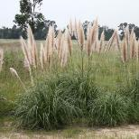 | PAMPAS GRASS  Scientific Name: Cortaderia selloana  Alternative Common name: Common pampas grass  Origin: South America (Brazil, Uruguay, Paraguay, Argentina and Chile  NEMBA Category: 1b  Read more: http://www.invasives.org.za/component/k2/item/228-common-pampas-grass-cortaderia-selloana
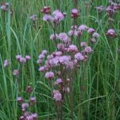 | POM POM WEED  Scientific Name: Campuloclinium macrocephalum  Alternative Common name: Pompom bossie (Afrikaans)  Origin: Central & South America (Mexico to Argentina)  NEMBA Category: 1b  Read more: http://www.invasives.org.za/component/k2/item/203-pom-pom-weed-campuloclinium-macrocephalum
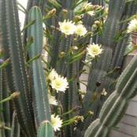 | QUEEN OF THE NIGHT  Scientific Name: Cereus jamacaru  Alternative Common name: Peruvian apple cactus (English); nagblom; bobbejaanpaal (Afrikaans)  Origin: South America  NEMBA Category: 1b  Read more: http://www.invasives.org.za/component/k2/item/203-pom-pom-weed-campuloclinium-macrocephalum
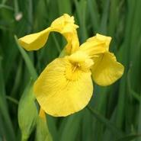 | YELLOW FLAG IRIS  Scientific name: Iris pseudacorus  Alternative common names: Yellow flag, yellow iris (English); geel iris (Afrikaans).  Origin: Europe, western Asia and parts of North Africa.  NEMBA Category 1a  Read more: http://www.invasives.org.za/component/k2/item/660-yellow-flag-iris-iris-pseudacorus
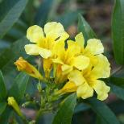 | YELLOW BELLS  Scientific name: Tecoma stans  Alternative common names: Yellow elder, ginger-thomas, yellow trumpet bush (English); geelklokkies (Afrikaans); insimbephuzi (isiZulu)  Origin: Mexico and Texas, Arizona and New Mexico in the United State  NEMBA Category 1a  Read more: http://www.invasives.org.za/component/k2/item/319-yellow-bells-tecoma-stans
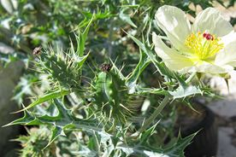 | WHITE-FLOWERED MEXICAN POPPY  Scientific Name: Argemone ochroleuca  Alternative Common name: Devil’s fig; Texas poppy (English); Witblombloudissels (Afrikaans); ugudluthukela (isiZulu)  Origin: Mexico  NEMBA Category: 1b  Read more: http://www.invasives.org.za/component/k2/item/233-white-flowered-mexican-poppy-argemone-ochroleuca-subsp-ochroleuca

What you can do to help
- Become informed about the impact of invasive alien plants and invasives of other species
- Remove invasive plants from your garden and neighbourhood
- Join a local hack (invasive clearing) group
- Bring invasive species to the attention of others
- Take a decision to plant only indigenous plants and encourage others to do the same
Useful sites to visit:
- http://www,invasives.org.za
- http://www.agis.agric.za/wip / (Weeds and Invasive Plants)
- http://www.sanbi.org/information-resources/.../invasive-alien-plant-alert
- http://www.environment.gov.za

Acknowledgements to www.invasives.org.za for the information contained in this leaflet
Visit this website for more information about invasive species that could be in your area and steps that can be taken to combat the problem.

