JAEI Environmental Corner
World Oceans Day

Theme for 2016 – “Healthy oceans, healthy planet”

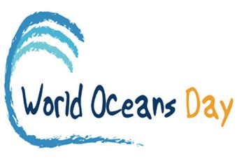
World Oceans Day is 8th June is the United Nations’ recognised day of ocean celebration and action.
This year, people all over our blue planet are celebrating with the theme “Healthy Oceans, Healthy Planet.” This year the major focus is on plastic pollution

Why should we recognise World Oceans Day?
A healthy world ocean is critical to our survival. World Oceans Day provides a unique opportunity to honour, help protect, and conserve the world’s oceans. Oceans are very important:
- They generate most of the oxygen we breathe
- They help feed us (Fish supply the greatest percentage of the world's protein consumed by people. More than 3.5 billion people depend on the ocean for their primary source of food. In 20 years, this number could double to 7 billion)
- They regulate our climate
- They clean the water we drink (crucial part of the Hydrological [water] Cycle)
- They offer a pharmacopoeia of medicines
- They provide limitless inspiration!
The ocean is the heart of our planet.
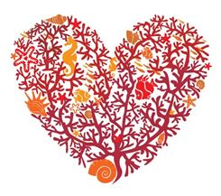
Like your heart pumping blood to every part of your body, the ocean connects people across the Earth, no matter where we live. The ocean regulates the climate, feeds millions of people every year, produces most of the oxygen we breathe, is the home to an incredible array of wildlife, provides us with important medicines, and so much more! In order to ensure the health and safety of our communities and future generations, it’s imperative that we take the responsibility to care for the ocean as it cares for us.
But disaster looms in the massive Oceans - an environmental catastrophe of gigantic proportions and it is all of our own making.
First invented in 1856, and lauded as one of the greatest invention of all times, plastic today threatens the survival of our marine world, and ultimately us! Of an estimated one trillion plastic bags used and discarded each year, only a measly 1% is recycled. So what happens to the rest? Some lands up in landfills, where through rain wind and weathering, can break down into smaller particles that find its way to the waterways and ultimately into the oceans. This is of course, not taking into account those bags and other plastic containers, bits and pieces that avoid the landfills and go straight for the waterways and land up in the oceans directly – all this through careless human neglect. This human negligence has fuelled the plastic plague of mega proportions that we find in our oceans today – a silent killer.
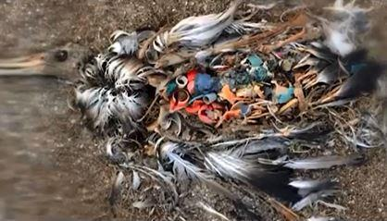Albatross from Midway Island in the Pacific died from eating plastic. Its stomach was crammed with rubbish – mostly plastic debris.
Plastic has a longer lifespan than we do, can travel much further that we could ever dream of, and threatens to destroy us. We treat the oceans as if they were giant rubbish-bins, and our sea life is choking on the contents.
Whilst plastic products haves certainly made life easier for us in many respects, for marine life, this debris becomes a floating minefield – entangles, chokes and suffocates them. Nearly 8 million tons of plastic is washed into the oceans each year – and most of it gets caught up in a network of currents that circulate water around the world. These massive, slow rotating whirlpools collect plastic and because plastics are designed to last – the plastic trash will remain in the oceans for decades or even longer. Sadly, animals don’t know the difference between food and trash
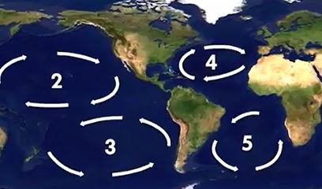
Rotating whirlpools – call “gyres: that form in the oceans and collecting plastic debris.
As much as 88% of the open ocean’s surface contains plastic debris.
Three main types of plastic debris occur:
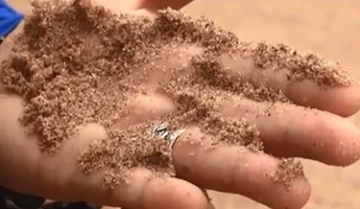
A handful of sea sand can have more plastic particles than sand grains
- Large plastic – bottles, fomo-paks, etc.

- Micro-plastics (Micro-beads from toothpastes, cosmetics and other cleaning products) pose an even more sinister threat to both human and animals. More than 70% of fish have plastic fragments, plastic beads and plastic fibres in them. In the ocean, sunlight and waves cause floating plastics to break into smaller particles, but they never completely disappear or biodegrade. Some pieces of plastic are so tiny that fish ingest them without know it – and then … we eat that fish! Each wave brings hundreds of thousands of pieces of plastic onto the beach, some pieces are so small and white that they look just like tiny grains of sand and there is no way that these particles can ever be cleaned up.

- Plastic fibre – plastic from the washing machine when washing polar fleece garments and throws. During the wash cycle, fibres are scraped off and these fibres go down the drain through the waste water treatment works (as they are far too small to be removed) and float into the rivers and become part of the plastic pollution menace of the ocean. These miniscule pieces of plastic and fibres form perfect tiny rafts where marine bacteria can grow. Micro plastics by themselves aren’t very sticky, but with the added bio-film growing on them from the bacteria forms a mucous-like structure on the plastic, POPs (particulate organic pollutants) stick to these plastics a lot more, travel further and accumulate more pollutants. Fish ingest these particles and through bioaccumulation, become sick and when these fish are eaten by us – we too, are at risk.
Every organism in the ocean is being affected, from filter feeders (sea urchins, mussels, plankton and even whales) which feed on microscopic sea creatures floating in the water to fish and sea birds – all are ingesting plastic
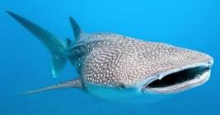The largest fish in the world – the enormous Whale-shark is a filter-feeder feeding exclusively tiny life-forms like plankton & fish eggs
By 2025, the amount of plastic added to our seas annually could reach 155 tons unless waste management techniques drastically improve.
Negligent disposal of plastic in Johannesburg will ultimately end up in the ocean and is contributing to the plastic pollution in our oceans – what a scary thought! Millions of species, including us are threatened by plastic pollution. We depend on our oceans for food and oxygen (Yes, oxygen! – did you know that 60% of the oxygen that we breathe comes from the ocean!) and the oceans are key in helping to balance greenhouse gases – so if the oceans die – so do we.
(Acknowledgements to 50/50 TV)
The “5-Rs” (Respect, Reduce, Reuse, Repair, Recycle) are no longer an option, but are critical for everyone to practice for our very survival.
So we can see that Plastic Pollution is a very real and recent man made catastrophe, and it is persistent, pervasive and pernicious. Once it gets into the Oceans it causes untold damage to the environment and ecosystems, damaging coastal economies and ultimately affecting all life on the planet – including human health

Each of us can be part of the solution right NOW!
- Change perspective – as individuals, we can think about what the ocean means to us, and all that it has to offer us, with hopes of conserving it for present and the future generations.
- Learn – Let’s discover the wealth of diverse and beautiful ocean creatures and habitats, how our daily actions affect them, and how we are all interconnected.
- Change our ways – we are all linked to, and through, the ocean! By taking care of our backyards and helping in our communities, we can act as caretakers of our ocean. Making small modifications to our everyday habits will make a difference, and involving our family, friends, and community will benefit our blue planet even more!
- Celebrate – whether you live inland or on the coast, we are all connected to the ocean. Take the time to think about how the ocean affects you, and how you affect the ocean, and then organize or participate in activities that celebrate our ocean.

Meditation

Prayer for Healing, Prayer for the Ocean
Close your eyes and breathe deeply. Imagine yourself walking along a beach. It’s a perfect day. Breathe in peace and love. Let go of any pain or fear. Move forward in your bare feet. You can feel every step. The sea-sand is cool beneath your feet. Sometimes your tender skin bakes in the sun-warmed sand. But there’s the cooling lapping water to dip your feet in after you’ve walked and walked.
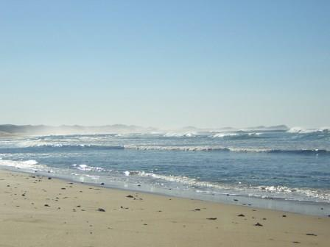
You feel happy and free because you know that all things are possible. There’s time to stop and look at the shells, stones and bits of seaweed now - whatever catches your attention. There are notes written in the sand from those that have come before you. They say things like Hope, Peace, and Love. Little reminders of all that is good.
After a while, you sit down to rest and watch the waves as they break and make their way to shore, the breeze catches the waves causing a gentle spray. The sun is warm and comforting. You feel as though you could sit there for days. You look up and watch a seagull gliding across the waves, letting the wind carry it over and up, around and down. Tears sting your eyes and love fills your heart. The seagull is so free and glorious in its flight.
Your eyes take in the brilliance, the glitter, the glorious colours – the blues, greens and white. How long will you watch the waves? You never tire of that. And the sounds are mesmerizing - the surf, the sea birds, the breeze and your own breath, in and out. The air is crisp and sharp – fresh and salty. The vast sea is full of life and death all at the same time. Beauty and fierceness. It’s a mirror of our souls. We are so small and yet so vast.

Prayer:
God, our Creator, as we reflect on the mysteries of the ocean depths, we celebrate the wondrous design of the seas that surround us. Help us to discern how we have polluted our oceans and to empathise with the groaning of creation beneath us. Teach us to sense your presence in the tides and currents of the surging seas. Teach us to care for the oceans and all our waterways. In the name of the Jesus Christ, our Lord, the creative force that designs and governs all creation. Amen
Forgive us, Lord, for all that we have done to harm the Oceans. There is light in us and we send it out on this night to the ocean, the earth, and all the creatures that inhabit this planet. May this great force that is within us be strong enough to heal us. We are all one: the earth, the ocean, everything - everyone.

