**JAEI ENVIRONMENTAL CORNER**

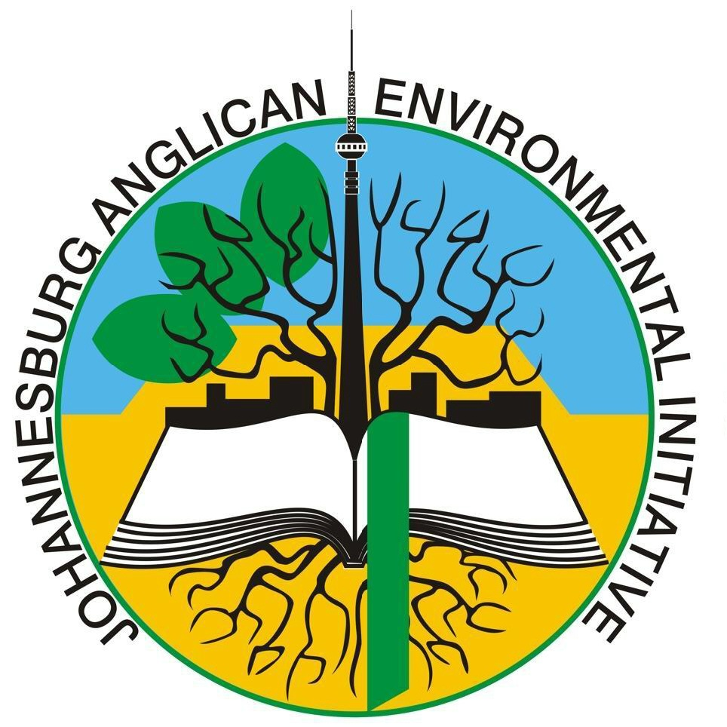

## September is coming!

## September is SEASON OF CREATION month –so let’s celebrate!!

*So, why are we talking about Season of Creation now? …. in June?* – when the chills of winter are making themselves felt? – because this will give you enough time to do some forward planning and prepare wonderful Season of Creation celebrations! … *and you may also want to actively initiate a greening programme within your Parish.*

How often do we stop, think and give thanks and praise to God for his Creation? How often do we acknowledge the times when we contribute to its destruction? How often do we consciously care for it? How often do we consciously acknowledge and put into practice the Anglican Churches’ Fifth Mark of Mission - ***“To strive to safeguard the integrity of creation and sustain and renew the life of the earth”.***

Perhaps you are unsure how to go about this – well, don’t despair – there’s oodles of help available! – just waiting for you to tap into it!

* There are three Season of Creation books (available from the Publications Department (at a cost of R30 per book) – or free downloads from [www.jaei.org.za](http://www.jaei.org.za) ) These are valuable resources for your planning and preparation.
* Members of our Environmental Department, JAEI (Johannesburg Anglican Environmental Initiative) will gladly give you advice and ideas. (JAEI will also gladly help you with a Parish greening programme.) Contact them through Noeleen – [noeleen@jaei.org.za](mailto:noeleen@jaei.org.za)
* JAEI can provide you with wonderfully inspiring Environmental Liturgies for your use.

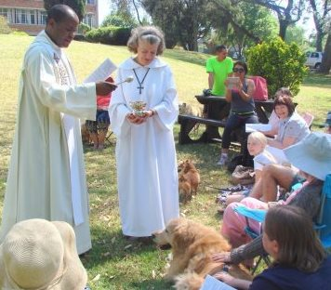

*Fr Moses of St Thomas, Linden, blesses the pets*

* Ideas for Services can be:
  + Have an environmental Liturgy, prayers and hymns
  + Hold a Service outside
  + Invite a guest preacher/speaker
  + For the brave! …. ***Bless the pets*** (St Francis Day marks the end of Season of Creation – so Sunday, 2nd October would be perfect for this)
  + Involve the Sunday School is a Spring celebration
  + Plant one of the Trees of the Year *(see below)*
  + Hold a flower festival
  + Hold a prayer hike
  + Have a clean-up day in the community (can coincide with National Clean-up Day)
  + Have a recycle craft day for the kids (coincide with Recycling Day) – *see below*
  + ***Come up with other inspiring ideas and share them with us!***

***Season of Creation AND Spring – what a wonderful combination! Let’s celebrate God’s Awesome Creation in its fullest!! Get planning right NOW!!!***

***What else happens in September that can be incorporated into your celebrations? …..*** *(more about these topics closer to the time)*

***1 September* – World Vulture Day**

**OUR RESPONSE AS THE BODY OF CHRIST**

* *Give thanks for the beauty and important part that these majestic birds play in our eco-systems.*

Vultures are an ecologically vital group of birds that face a range of threats in many areas that they occur. Populations of many species are under pressure and some species are facing extinction.

***1st week in September* - Arbor Week**

**OUR RESPONSE AS THE BODY OF CHRIST**

* *Give thanks for the incredible beauty, variety and diversity of plants in our Country. Pray for forgiveness when we have taken this beauty for granted and pray that each one of us will utilize this resource wisely.*

As sources of building material, food, medicine, and simple scenic beauty, trees play a vital role in the health and well-being of our communities.

The 2016 trees are:

* ***Common tree*** - Common Wild Fig (Gewone Wildevy) *Ficus thonningii (Grows into a VERY big tree – be careful where you plant it if you do!)*
* ***Rare tree*** - Common Bush-cherry (Gewone Witbos) *Maerua cafra and B*ead-bean Tree (Knoppiesboontjieboom) *Maerua angolensi*s

|  |  |  |
| --- | --- | --- |
| *Common Wild Fig (Gewone Wildevy) Ficus thonningii* | *Common Bush-cherry (Gewone Witbos) Maerua cafra* | *Bead-bean Tree (Knoppiesboontjieboom) Maerua angolensis* |

*More about these trees closer to the time…..*

***So, grab a shovel and plant a tree for Arbor Week, an environmental campaign to promote a more beautiful South Africa and celebrate God’s Awesome Creation!***

***16 September* - International Day for the Preservation of the Ozone Layer**

**OUR RESPONSE AS THE BODY OF CHRIST**

* *See “Season of Creation” Pages 30 – 35 for information, Liturgical, and prayer suggestions for “Climate Change”*

This invisible layer in the atmosphere protects the Earth from harmful ultra-violet rays from the sun. Should these ultra-violet rays reach Earth by passing through the thinning ozone layer, skin cancer and damage to crops will increase. Ozone depleting substances such as chloro-fluorocarbons (CFCs), hydro-fluoro-carbons, methyl bromide, to mention a few, are pollutants used all over the world. By observing this day, we are reminded of the necessity to live in ways that do not contribute to the depletion of this vital and essential layer of atmosphere that shields the Earth. It also gives individuals and organisations time to reflect on what progress has taken place to combat this environmental threat.

***3rd Week in September* – National Clean-up Week & *20 September* – Recycling Day**

**OUR RESPONSE AS THE BODY OF CHRIST**

* *See “Season of Creation” Pages 18 - 23 for information, Liturgical, and prayer suggestions regarding “Need not Greed”*
* *Organise a Clean-up day in your Community.*
* *Set up a recycling centre at your Church*
* *Hold a recycle craft day for the children. (if you need help with ideas – contact Noeleen at* [*noeleen@jaei.org.za*](mailto:noeleen@jaei.org.za)*)*

During this week all South Africans are urged to do something towards cleaning their local community. The focus of an individual clean-up may vary and will depend on issues pertaining to a particular community.

Recycling Day South Africa encourages South Africans to recycle at home, school and at work and buy products made with recycled material. This day occurs during National Clean-Up Week and aims to increase awareness by educating the community about the social, environmental and economic benefits of recycling

***21 September* – International Peace Day**

**OUR RESPONSE AS THE BODY OF CHRIST**

* *Pray for unity within all the Peoples of South Africa – that each may see themselves as part of God’s Creation and live in harmony with it.*

The marking of this day is intended to have the entire world observe a day of peace and non-violence and all organisations and individuals are encouraged to observe this day in an appropriate manner. Conflict and tensions amongst people in South Africa, is unfortunately, still prevalent. This day reminds us of our continuing need to work together and put our differences

***22 September* – World Rhino Day**



**OUR RESPONSE AS THE BODY OF CHRIST**

* *Pray for all those involved in rhino conservation – for strength and endurance. Pray for those involved in the heinous act of poaching – that their hearts may turn to love of these creatures and away from their illicit dealings.*

Rhino horns, unlike those of other horned mammals (which have a bony core), only consist of keratin. Rhinoceros horns are currently used mainly in traditional Asian medicines. Sadly, few people realize the challenges facing those on the frontlines trying to protect our precious rhinos – including, having inadequate resources and thousands of kilometres to patrol, with little to no idea of where the poachers plan to hit next. World Rhino Day celebrates all five species of rhino and works to eliminate the demand for rhino horn by highlighting efforts to debunk the medicinal myths about rhino horn. South Africa is home to the White and Black Rhino.

***24 September* – Heritage Day**

**OUR RESPONSE AS THE BODY OF CHRIST**

* *Pray for unity within all the Peoples of South Africa – that each may be seen as a Child of God and respect and care for all creatures*

Natural and cultural heritage include monuments, architectural works, sculpture and painting, structures of an archaeological nature, inscriptions, cave dwellings and groups of buildings. Also included are sites of outstanding universal value from an historical, aesthetic, and ethnological point of view to geological and physiographic formations and natural sites. Of the 981 cultural and natural properties forming part of the World Heritage List, which the World Heritage Committee considers as having outstanding universal value, eight can be found in South Africa alone. The need to acknowledge this rich and varied cultural heritage

**There is *SO* much happening in Season of Creation Month – September**

***SO*** much to celebrate, ***SO*** much to give thanks to an Awesome, Generous God, but also a time to look at our contribution to its destruction …. Where ***WE*** need to change - our lifestyles, our consuming patterns, our neglect, our apathy …..

**A Prayer of Awareness  
*Hildegard of Bingen***

**God is the foundation for everything   
This God undertakes, God gives.   
Such that nothing that is necessary for life is lacking.   
Now humankind needs a body that at all times honours and praises God.   
This body is supported in every way through the earth.   
Thus the earth glorifies the power of God.**