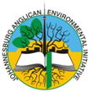
JAEI Enviro-corner
Climbing a great hill – Reflections on the Paris climate talks from the steering group of the Anglican Communion Environmental Network (ACEN)
Taken directly from http://www.anglicannews.org/news/2015/
Posted on: December 18, 2015 2:32 PM

Although it has been a few months since the COP21 meeting in Paris – it is still worthwhile to look back and reflect on the talks.
In the Long Walk to Freedom, Nelson Mandela said “After climbing a great hill, one only finds that there are many more hills to climb”.
A great hill was climbed at COP21
Something very significant happened at COP21, the Climate Talks in Paris. After two decades of fruitless talks, an agreement was reached. For the first time the world came together and agreed that climate change is serious and that we need to look to a post fossil fuel future.
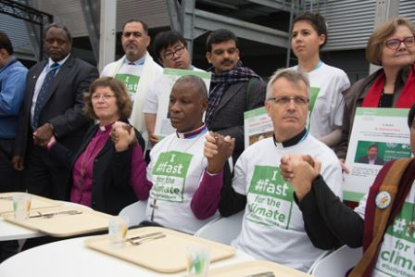Archbishop Thabo and other Religious leaders sit in front of empty plates during a media stunt promoting the Fast for the Climate campaign during the COP21 talks in Paris
In Paris, 195 nations agreed to try to curb global warming to well below two degrees Celsius and preferably below 1.5 degrees. It was agreed to try to reach net zero greenhouse gas emissions during the second half of this century.
Countries will meet every five years to review the progress of cutting emissions and the first review will take place in 2019. This process creates an opportunity for civil society and faith groups to keep the pressure on governments to increase their commitments to cutting emissions.
A post fossil fuel future is envisioned. A clear message was sent to markets and investors that the future of energy is in renewables like wind and solar. As the price of renewable energy drops, the move towards renewables will escalate.
Civil society and faith groups played an important role in the run-up to COP21
What happened inside the UN negotiations was only a part of what took place globally. The Paris talks became a catalyst and millions of people mobilized around the world in marches, protests, fasts, prayers, pilgrimages and petitions. Multiple agencies gathered the voices of over 6.2 million people who demanded that governments make a fair and legally binding agreement.
The Primate of the Anglican Church of South Africa and chair of the Anglican Communion Environmental Network, five Anglican bishops and representatives of the Anglican Alliance were among a significant group of Anglicans who travelled to Paris bringing messages from communities struggling with the impacts of climate change.
We are truly grateful to all Anglicans the world over who walked, fasted, prayed during the Pilgrimage to Paris.
The role of Pope Francis in galvanising faith communities cannot be underestimated. Fast for the Climate and Pray4COP21 also brought together major Christian organisations to work and pray together.
Other commitments were made at Paris.
Many exciting initiatives were announced in Paris to give cities, companies, and private citizens a bigger role in speeding up the transition to a clean energy economy. For example, nearly 400 cities have signed up for the Compact of Mayors coalition to measure and reduce emissions. Twenty countries – including the USA – pledged to double their investment in clean energy research and development and private investors also announced sizable commitments in this area. We are seeing the price of solar, wind, and battery technologies plummeting.
More Hills to climb
However, we have only climbed the first of many hills, there are many more to climb.
The Paris agreement was not enough.
The Intended Nationally Determined Contributions (INDCS) tabled by countries before COP21 put us on a path to 2.7 degrees at the most optimistic. Parts of this deal have been diluted and polluted by companies that despoil our planet. There is not enough in it for the nations and people on the frontlines of climate change. It contains an inherent, ingrained injustice. The countries which caused this problem have promised too little to help the people who are already losing their lives and livelihoods in climate impacts.
Pledges come into force too late. The pledges will only come into force in 2020, by which time the nations will probably have used the entire carbon budget to keep warming below 1.5 degrees. If countries stick with their INDCs we are likely to experience warming between 2.7 degrees and 3.7 degrees.
Deforestation and agriculture are not addressed: The Paris agreement does not talk about the livestock, palm oil and other industries which are driving deforestation. Neither does it tackle the greenhouse gases such as methane caused by commercial agriculture.
The Paris agreement does not tackle the issue of fossil fuel subsidies. Governments currently spend an estimated $5,300 billion per year on direct and indirect subsidies to fossil fuels. These funds need to be diverted to renewable energy and climate resilience.
The Pilgrimage to Paris has come to an end, but the journey continues
We must step things up another notch and make sure the promises are kept, and strengthened. We must build on the alliances formed and grow new ones. We need to organize to keep fossil fuels in the ground and accelerate a just transition to 100% renewable energy.
“For creation waits in eager expectation for the children of God to be revealed”. Romans 8:19
ACEN represents the environmental and climate justice leadership of the 38 Provinces of the global Anglican Communion. Our network has a diverse membership from Anglican congregations in countries that are the most vulnerable to the effects of climate change to major greenhouse gas emitting nations.
Together, we seek a shared vision of the Christian life put into a new practice; a vision that integrates spirituality and discipleship with justice, sustainability, and economic development. To fulfil this vision of the Christian life, we believe we must break the spell of unbridled consumerism, while forming ecumenical and inter faith alliances and seeking the perennial wisdom of indigenous peoples with whom we stand in solidarity.
In 2015, ACEN brought together in Cape Town, South Africa, 17 bishops from across the Anglican Communion who are already deeply involved in the climate crisis. Their bold statement, “The World is Our Host”, calls upon the entire membership of the Anglican Communion to take bold, immediate public actions. Among these actions are divestment from fossil fuels, addressing the rising tide of refugees as a result of climate change, and the transformation of congregational life through carbon fasting and holding up the ecological dimensions of our sacramental life through water (Holy Baptism) and food (Holy Eucharist).
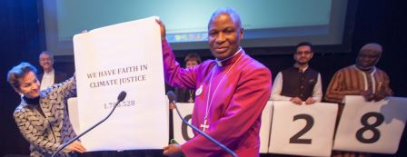
Archbishop Thabo with Christiana Figueres (Executive Secretary of the UN Framework Convention on Climate Change of the UN) at COP 21 in Paris

We continue to pray for our Planet:
All-powerful God, you are present in the whole universe and in the smallest of your creatures.
You embrace with your tenderness all that exists.
Pour out upon us the power of your love, that we may protect life and beauty.
Fill us with peace, that we may live as brothers and sisters, harming no one.
O God of the poor,
help us to rescue the abandoned and forgotten of this earth, so precious in your eyes.
Bring healing to our lives, that we may protect the world and not prey on it,
that we may sow beauty, not pollution and destruction.
Touch the hearts of those who look only for gain at the expense of the poor and the earth.
Teach us to discover the worth of each thing, to be filled with awe and contemplation,
to recognize that we are profoundly united with every creature as we journey towards your infinite light.
We thank you for being with us each day
Encourage us, we pray, in our struggle for justice, love and peace. Amen
- Pope Francis

