JAEI Environmental Corner

2016 is the International Year of Pulses …

and the buzz starts with YOU!

The 68th UN General Assembly declared 2016 the International Year of Pulses (IYP).
The Food and Agriculture Organisation of the United Nations (FAO) has been nominated to facilitate the implementation of the Year in collaboration with Governments, relevant organizations, non-governmental organizations and all other relevant stakeholders.
The IYP 2016 aims to heighten public awareness of the nutritional benefits of pulses as part of sustainable food production aimed towards food security and nutrition. The Year will create a unique opportunity to encourage connections throughout the food chain that would better utilize pulse-based proteins, further global production of pulses, better utilize crop rotations and address the challenges in the trade of pulses.

What are pulses and why are they important?
Pulses are annual leguminous crops yielding between one and 12 grains or seeds of variable size, shape and colour within a pod, used for both food and feed. The term “pulses” is limited to crops harvested solely for dry grain, thereby excluding crops harvested green for food, which are classified as vegetable crops, as well as those crops used mainly for oil extraction and leguminous crops that are used exclusively for sowing purposes (based on the definition of “pulses and derived products” of the Food and Agriculture Organization of the United Nations).
Pulse crops such as lentils, beans, peas and chickpeas are a critical part of the general food basket. Pulses are a vital source of plant-based proteins and amino acids for people around the globe and should be eaten as part of a healthy diet to address obesity, as well as to prevent and help manage chronic diseases such as diabetes, coronary conditions and cancer; they are also an important source of plant-based protein for animals.
In addition, pulses are leguminous plants that have nitrogen-fixing properties which can contribute to increasing soil fertility and have a positive impact on the environment.
The Food and Agriculture Organisation of the UN is addressing this campaign in four areas:
- Food Security, Nutrition & Innovation
- Creating Awareness
- Productivity & Environmental Sustainability
- Market Access & Stability

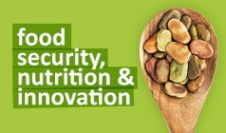
Pulses are part of a healthy, balanced diet and have been shown to have an important role in preventing illnesses such as cancer, diabetes and heart disease.
Pulses are a low fat source of protein, with a high fibre content and low glycemic index.
Pulses are very high in fibre, containing both soluble and insoluble fibres. Soluble fibre helps to decrease blood cholesterol levels and control blood sugar levels, and insoluble fibre helps with digestion and regularity.
Pulses provide important amounts of vitamins and mineral. Some of the key minerals in pulses include: iron, potassium, magnesium and zinc. Pulses are also particularly abundant in B vitamins; including folate, thiamin and niacin.
Pulses typically contain about twice the amount of protein found in whole grain cereals like wheat, oats, barley and rice, and in most developing countries constitute the main source of protein for most populations.
In addition to contributing to a healthy, balanced diet, pulses nutritional qualities make them particularly helpful in the fight against some non-communicable diseases.
The World Health Organisation estimates that up to 80% of heart disease, stroke, and type 2 diabetes and over a third of cancers could be prevented by eliminating risk factors, such as unhealthy diets and promoting better eating habits, of which pulses are an essential component.
Pulses can help lower blood cholesterol and attenuate blood glucose, which is a key factors in against diabetes and cardiovascular disease. Eating pulses as a replacement to some animal protein also helps limit the intake of saturated fats and increases the intake of fibres.
Pulses have also been shown to be helpful in the prevention of certain cancers, because of their fibre content but also because of their mineral and amino-acid contents, in particular folate.
Pulses are included in all ‘food baskets’ and dietary guidelines. The World Food Programme (WFP) for instance includes 60 grams of pulses in its typical food basket, alongside cereals, oils and sugar and salt.
Encouraging awareness of the nutritional value of pulses can help consumers adopt healthier diets. In developing countries, where the trend in dietary choices tends to go towards more animal based protein and cereals, retaining pulses is an important way to ensure diets remain balanced and to avoid the increase in non-communicable disease often associated with diet transitions and rising incomes.
Several studies have shown that legumes are been associated with long-lived food cultures such as the Japanese (soy, tofu, natto, miso), the Swedes (brown beans, peas), and the Mediterranean people (lentils, chickpeas, white beans) and that they could be an important dietary factor in improving longevity.
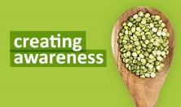
The 2016 International Year of Pulses is the single largest opportunity to increase awareness of pulses many of us will ever see. In many countries, consumer, food industry members, and governments have little knowledge of pulses, their attributes, or their ability to contribute to the solution of many food-related issues facing the world today.
IYP 2016 will aim to increase awareness of pulses globally, and to increase demand, utilization, and production of pulses worldwide. Using all platforms - events, campaigns, websites and social media – it is ensured that by the end of 2016, more people know pulses, and know about them

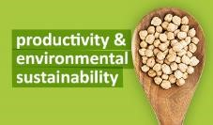
Pulses and Sustainability
Pulses play an important role for sustainability in many ways. They are an important component of crop rotations, they require less fertilisers than other crops and they are a low carbon source of protein.
Legumes are part of the rotational crops farmers can use to maintain soil fertility. In Canada for instance, where pulses are often integrated in good soil management practices, a good crop rotation includes a variety of crops grown in sequence, including cereals (wheat, barley, oats), oilseeds (canola, flax, sunflowers), and legumes (pulses).
Pulses have a positive impact on soil quality because they help fix nitrogen in the soil. This contributes to higher yields in subsequent crop rotations.
However, it is not the only reason. Pulses have a direct positive impact on soil quality because they help feed soil microbes, which benefits soil health. Pulses have also been shown to produce greater amounts and different types of amino acids than non-legumes and the plant residues left after harvesting pulse crops have a different bio-chemical composition than other crop residues.
It is this diversity in soil composition that comes from a good pulse rotation, which help crops to thrive and which offers greater protection against disease-causing bacteria and fungi.
Pulses are also a protein source with a low footprint, in both carbon and water. For instance, the water footprints to produce a kilogram of beef, pork, chicken and soybeans are 43, 18, 11 and 5 times higher than the water footprint of pulses.
Pulses have a lower carbon footprint in production than most animal sources of protein. In fact, one study showed that one kilogram of legume only emits 0.5kg in Co2 equivalent, whereas 1kg of beef produces 9.5 kg in CO2 equivalent.
The very low contribution of legumes is well illustrated in the graph below.
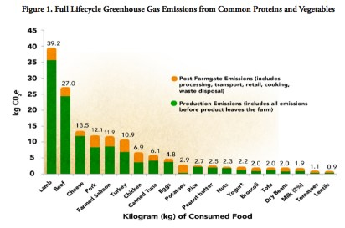
Full Lifecycle Greenhouse Gas Emissions from Common Proteins and Vegetables
It shows that lentils are one of the foodstuffs that contributes the least emissions, far fewer than turkey, salmon or other common sources of protein.
Nitrogen is the nutrient most needed in crop production and nitrogen fertiliser is manufactured using natural gas. But as above, pulses are quite unique among other crops, as they draw their own nitrogen from the air, so do not require the same application of nitrogen fertiliser as other crops.
By fixing nitrogen in the soil, pulses also help reduce the footprint of other crops so the benefits extend much further into the food production cycle.
For example, a recent study showed that durum wheat preceded by a biological nitrogen-fixing crop, such as chickpeas or lentils the previous year lowered its carbon footprint by 17% compared with durum preceded by a cereal crop. The impact was even stronger is a pulse-pulse wheat system, with the carbon footprint of the durum wheat down by 34% compared to a traditional cereal-cereal–durum rotation.

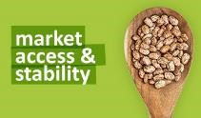
Pulses and Rural Development
Pulses are economically important crops for farmers, in both developing and developed countries. 70% of pulse production globally (except for dry peas) comes from developing countries. For instance, India produces about a quarter of the world’s pulses, which in 2011 amounted to 17 million tonnes. In developing countries, smallholder farmers play an important role in growing pulses, often mostly for their own consumption but also to sell locally.
Low productivity can represent an important impediment in making pulses a valuable source of additional income, but with the introduction of improved varieties and better management techniques, important increases yields can be achieved. A study in West Africa showed that pulses often have higher markets prices than cereal crops. For instance, soybeans sold for 46 naira/kg, whereas maize sold for 17 naira/kg in Nigeria. Similarly, in Ethiopia, chickpeas yield about ETB 720, whereas barley yielded only 180.
Addressing productivity issues could help small farmers improve their livelihoods considerably. IFPRI’s study in Ethiopia estimated that productivity gains from improvements in planting techniques could double overall pulse production to two million tons over a period of five years. This gain in productivity would increase smallholder income by 40 to 70 percent per hectare. This could contribute to incomes and improved food security by meeting demand for pulses locally.
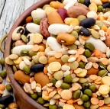
Many countries do not produce at sufficient levels to meet domestic demand, and so there is a market for producing pulses for export as well. For example, India consumed over 21 million tonnes of pulses in 2011, and yet it has imported pulses since the 1980’s in order to meet its domestic demand, including from Myanmar, China and Tanzania.
Developed countries, such as Canada and the USA, are also significant growers and pulses represent an important crop for farmers in those countries as well. For example, in 2010, Canada accounted for 32% of world pea production and 38.5% of world lentil production. In developed countries, where pulses have represented a less important part of traditional diets, a fair share of the production is destined for export. Canada accounts for approximately 35% of global pulse trade each year, reaching a value of nearly $2.7 billion in 2011[1].
Recognising the role that pulses can play in providing incomes for farmers is important. Investments are needed to ensure productivity and quality can be improved, so that pulses can be marketed, at local, regional and international level, creating a valuable addition to farmer’s livelihoods.

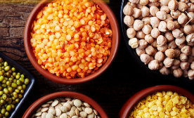
Pulses are:

Delicious and versatile

Heart-healthy and nutritious

Renewable and sustainable
How you can help:
- Host a recipe competition to find the best pulse dish at your Parish
- Cook with more pulses and share your recipes with your friends

Spread the word about these super foods. Your community - and your planet - will thank you!
Here are some delicious recipes to get you started!

Savoury Beef Mince
Good for your health and good for your pocket – and your carbon footprint, especially if you buy locally produced beef.
Prep time: 10 minutes | Cook time: 25 minutes | Serves 4-6 people
Ingredients
- 2 tablespoons olive oil
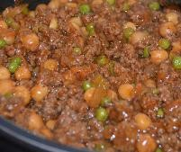
- 1 onion peeled and sliced
- 2 cloves garlic, peeled and chopped
- 500g / 1lb minced beef
- 2 carrots peeled and grated
- 2 sticks celery, finely chopped
- 1 400g can chick peas, drained and washed
- 4 tablespoons frozen peas
- 4 tablespoons tomato paste
- 250ml vegetable stock
- 2 teaspoons Worcester sauce
- 2 teaspoons dried mixed herbs
- 2 bay leaves
- salt and pepper to taste

Directions
- Heat the olive oil in a large frying pan
- Add the onions and fry gently on a medium heat until soft
- Add the garlic and celery and cook for a couple of minutes
- Add the meat, breaking it up and browning it
- Add the carrots, chick peas, stock and pasata
- Add the Worcester sauce and herbs
- Add the bay leaves
- Bring back to the boil and turn down the heat to a slow simmer
- Cook for about 25 minutes
- Serve with mashed potato, baked potato or rice and a vegetable or two
Chicken & lentil stew with gremolata
Prep time: 10 mins Cook time: 55 mins | Serves 4
Spruce up a light tomato-based casserole with a generous sprinkling of parsley, lemon and garlic, also known as 'gremolata'

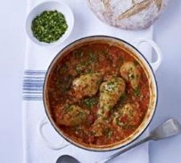
Ingredients
- 2 tbsp olive oil
- 8 chicken drumstick, skin left on
- 2 onions, very finely chopped
- 6 tbsp red lentil
- 400g can chopped tomato
- 1 chicken stock cube, crumbled
- crusty bread, to serve

For the gremolata
- zest of 1 lemon
- 1 garlic clove, finely chopped
- small handful parsley, finely chopped

Directions
- Heat half the oil in a large flameproof casserole dish, brown the drumsticks on all sides, then transfer to a plate.
- Add the onions and remaining oil to the pan, and cook for 5 mins or so until soft. Add the lentils, tomatoes, 1 can of water and the stock cube. Return the drumsticks to the pan. Bring to the boil, then turn down the heat, put on a lid and simmer for 30 mins or until tender. Keep an eye on the stew and add a little water if it is drying out. Remove the lid and cook for another 10 mins, or until the sauce has thickened, then season.
- Meanwhile, make the gremolata. Mix the lemon zest, garlic and parsley together. Sprinkle over the cooked stew and serve with a chunk of crusty bread.

Baked potatoes with spicy dhal

Ingredients
- 2 baking potato (Vivaldi have a lovely, creamy texture)
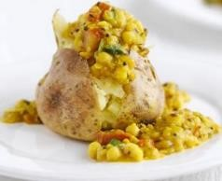
- 1 tbsp sunflower oil
- ½ tsp cumin seed
- ½ tsp black mustard seeds
- ½ tsp turmeric
- 1 onion, thinly sliced
- 3 garlic clove, sliced
- 1 red chilli, deseeded and sliced
- 85g red lentil
- 1 tomato, chopped
- 400ml vegetable stock
- 210g can chickpea, drained
- good handful chopped coriander
- chutney or lime pickle, to serve

Directions
- Heat oven to 180C. Put the potatoes in the oven and bake for 1hr until tender and the skin is crispy.
- While they are baking, make the dhal. Heat the oil in a medium pan and fry the spices to release their flavours. As soon as they start to crackle, tip in the onion, garlic and chilli, with a splash of water to stop the spices from burning. Cook for 5 mins until the onion softens.
- Add the lentils, tomato and stock, then cover and cook for 10 mins. Tip in the chickpeas, cover and cook for 10 mins more until the lentils are tender. Season to taste, stir in the coriander and spoon onto the jacket potatoes. Serve with chutney or lime pickle.
Hummus
Hummus is a dip/spread that is made from chickpeas. In fact, hummus is the Arabic word for chickpea. You may notice that many hummus recipes call for garbanzo beans, not “chickpeas.” - garbanzo is the Spanish translation of chickpea & they are called cece beans in Italy.
Hummus is one of the oldest foods dating back to ancient Egypt. We know that chickpeas were used quite frequently over 7,000 years ago.
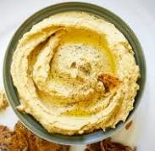
Butternut humus
- 1.5 cups roasted butternut squash
- 1.5 cups chickpeas (about one can of chickpeas, rinsed and drained)
- 1 tub cream cheese
- 2 garlic cloves, minced

- juice of 1 lemon
- 1/2 tsp salt
- 1/4 tsp paprika
- freshly ground pepper

Directions:
- Cook butternut
- Put all ingredients into a blender and blend until well-combined.
- Serve with veggies, crackers or dipping of choice.
- Will keep in fridge for up to 1 week.

Graces:

“God, many hands made this meal possible. Farmers grew it. Truckers drove it. Grocers sold it. We prepared it. Bless all those hands, and help us always remember our dependence on you. Amen.” (Norman Vincent Peale, A Prayer for Every Need)

For food in a world where many walk in hunger
For faith in a world where many walk in fear
For friends in a world where many walk alone
We give you humble thanks O Lord

