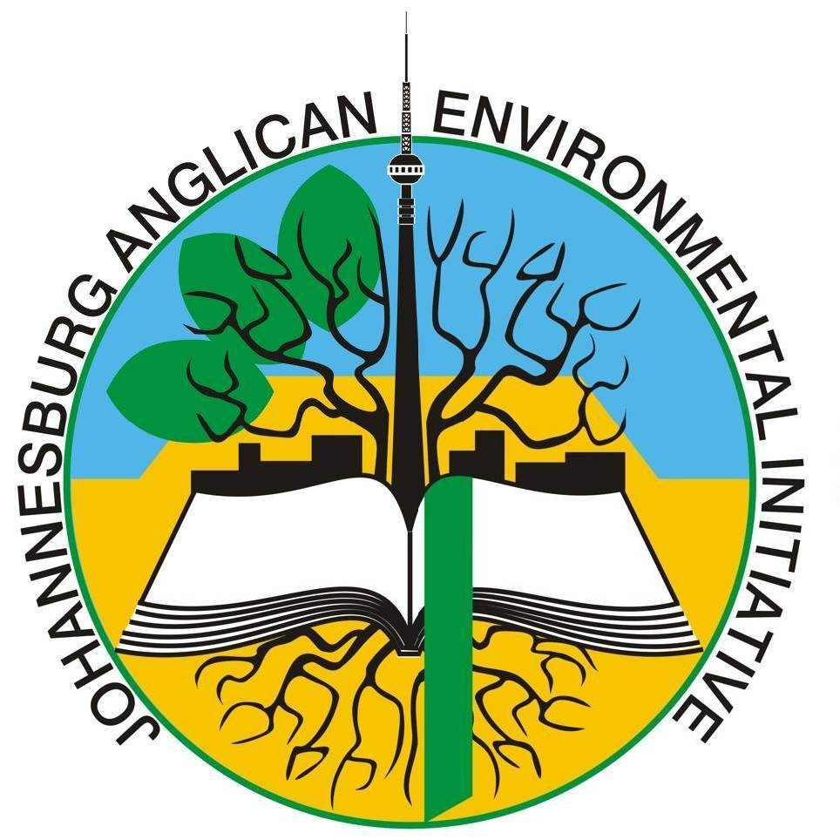
JAEI ENVIRONMENTAL CORNER

Climate Change is real!
Super Typhoon Haiyan, the most powerful typhoon in history, has sent a clear message to the Worlds’ Leaders at COP 19 (Conference of the Parties climate Change Conference – being held in Warsaw, Poland) that this is the time and they are the ones to vote decisively for Climate Justice. While we pray for the thousands who have lost their lives and livelihoods in the Philippines, lets also pray that the Leaders at COP 19 find the courage, integrity and generosity to make the health of the Planet and of current and future generations their overriding priority.
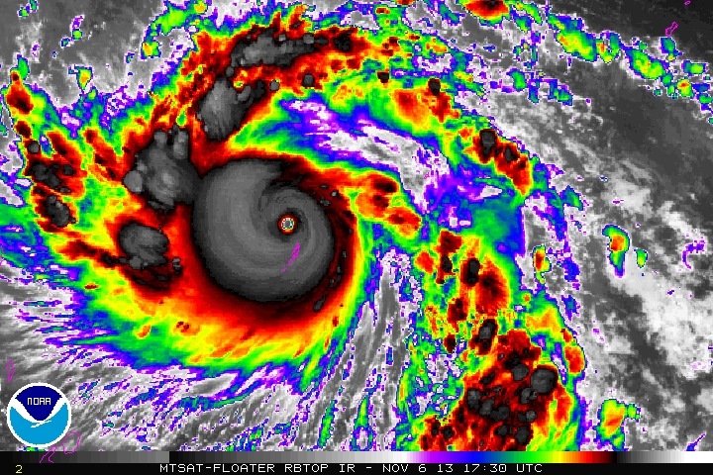
Satellite imagery of
Super Typhoon Haiyan,

Fasting for justice
Representatives of faith communities at COP19 have embarked on a fasting chain in solidarity with people in the Philippines and worldwide suffering from the effects of climate change. The fast will last until the end of the climate talks, on the 22nd November.
For all faith traditions, fasting has a strong spiritual meaning. It first and foremost allows us to meet our God. In the midst of necessary technical and political discussions, we step back, pray and reflect. Through the concrete sensation of hunger we do not only declare ourselves in solidarity with suffering, but we are actually in suffering with them.
We relate the climate negotiations with our responsibility as believers to care. As a principle of equity we fast and reduce because we can, for others who cannot."

Climate Facts are out!
The evidence is stronger than ever that human activity is the primary cause of the present Climate Change crisis. As communities in all parts of the world wonder how to prepare for once in a lifetime super storms that now happen every few years, the good news is that the IPCC’s latest report provides decision makers with clear estimates of the total allowable global greenhouse gas emissions in order to limit temperature rise. We have the knowledge and the means - but we need to find the will!

Join with us in praying the Climate Prayer daily:
Holy God,
earth and air and water are your creation, and every living thing belongs to you:
have mercy on us as climate change confronts us.
Give us the will and the courage to simplify the way we live,
to reduce the energy we use, to share the resources you provide,
and to bear the cost of change.
Forgive our past mistakes
and send us your Spirit, with wisdom in present controversies
and vision for the future to which you call us.
Amen
(Courtesy of the Anglican church of Australia)

