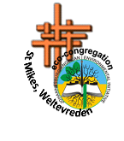
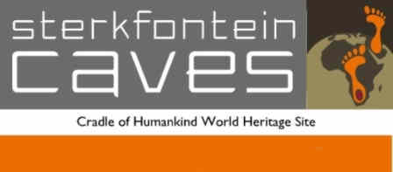
Sterkfontein Caves Outing
On Saturday, 16 July 2016, a group from St Mikes, Weltevreden, got to grips with the magnitude of the past when they visited the fascinating Sterkfontein Caves in the Cradle of Human Kind.
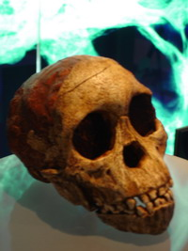
A UNESCO World heritage site, the Sterkfontein Caves are owned by Wits University, whose scientists have been responsible for the main excavations of the World Heritage Site. They are credited with many of the famous discoveries including the world famous “Mrs Ples” and “Little Foot”, an almost complete Australopithecus skeleton dating back more than 3-million years. Fossils preserved in these caves take us back in time, to creatures and plants that inhabited Earth long before us.
The Group were introduced to the magnitude of our past with a walk through the detailed, astounding and fascinating pre-cave exhibit. Most of the group were then able to venture into the glorious Caves themselves for the guided walk. Those that couldn’t manage the strenuous cave adventure, were able to take a leisurely stroll along the well-kept paths and board walks to take in the beautiful scenery and well-signposted information.
What a wonderful outing! – an eye-opening and fascinating peek into the secrets of God’s awesome Creation! thoroughly recommended to everyone!

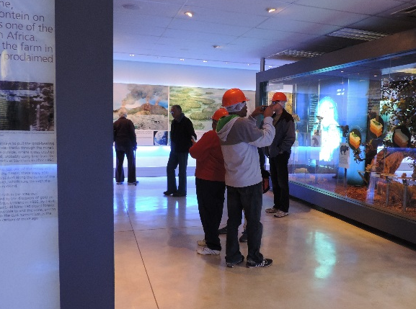 | 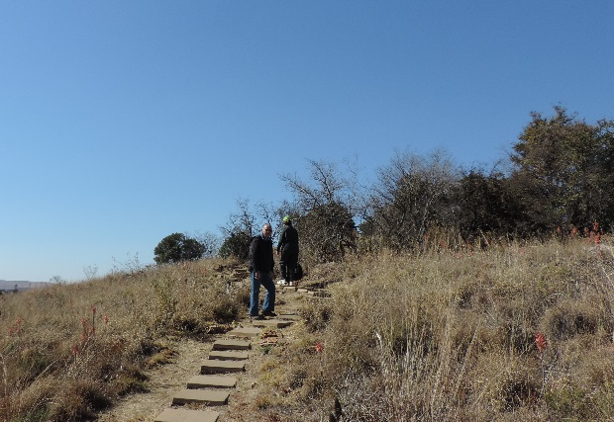
Taking in the information in the pre-cave exhibit | Strolling along the lovely paths
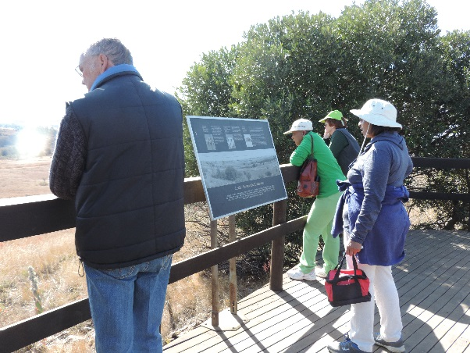 | 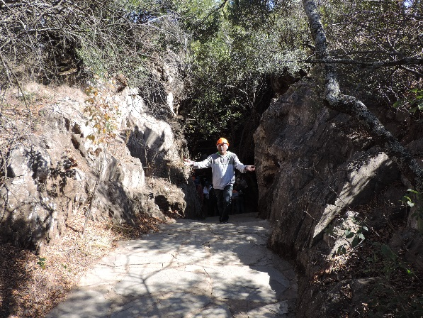
Interesting information signage along the boardwalks | Successfully completed the cave walk!

