“Painting in Nature Morning”
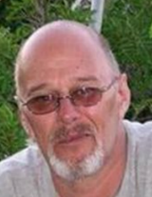
On 12 March a group of “would be” artists got together under the expert guidance of S Mikes, Weltevreden’s own acclaimed artist, David Moore.
The weather did not cooperate and the “in Nature” had to become “in hall” – where David set out an attractive still life for the group to use for their paintings.
Some of the group had literally never held a paint brush in their lives, and a few were quite adept – everyone excelled and had an awesome enjoyable morning!

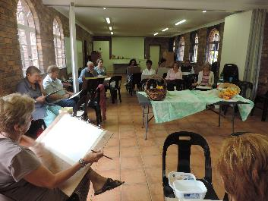 | 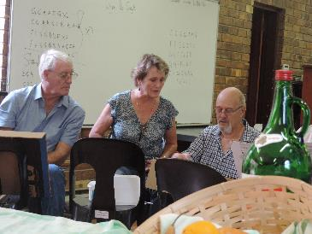
Hard at work! | Little bit of help here!

